|  |
| --- |
|  |
| Wikipedia |
| Prototype Documentation |
|  |
|  |
| **Presented by:**  **Akshay Choudhary**  **Garima Deshpande**  **Priyanka Pagare**  **Tejas Washindkar** |

[Type the abstract of the document here. The abstract is typically a short summary of the contents of the document. Type the abstract of the document here. The abstract is typically a short summary of the contents of the document.]

Table of Contents

1. Pages 14

1.1. Page Tree 14

1.2. Home_Tejas 15

1.2.1. User Interface+ 15

1.2.2. Widget Table 15

1.2.3. flipImg1 16

1.2.3.1. State1 16

1.2.3.2. User Interface 16

1.2.3.3. State2 17

1.2.3.4. User Interface 17

1.2.3.5. State3 18

1.2.3.6. User Interface 18

1.2.4. Unnamed 19

1.2.4.1. State1 19

1.2.5. flipImg2 19

1.2.5.1. State1 19

1.2.5.2. User Interface 19

1.2.5.3. State2 20

1.2.5.4. User Interface 20

1.2.5.5. State3 21

1.2.5.6. User Interface 21

1.3. Akshay_ChangeDate 22

1.3.1. User Interface 22

1.3.2. Widget Table 22

1.3.3. ONGOING EVENTS 23

1.3.3.1. State1 23

1.3.3.2. User Interface 23

1.3.3.3. Widget Table 23

1.3.4. CONTENT-SECTION2 24

1.3.4.1. State1 24

1.3.4.2. User Interface 24

1.3.5. TRENDING NEWS 24

1.3.5.1. State1 24

1.3.5.2. User Interface 24

1.3.5.3. Widget Table 24

1.3.6. CONTENT-SECTION1 25

1.3.6.1. State1 25

1.3.6.2. User Interface 25

1.3.7. MainPageDP 25

1.3.7.1. State1 25

1.3.7.2. User Interface 25

1.3.7.3. Widget Table 25

1.3.8. Interaction_DP 26

1.3.8.1. State1 26

1.3.8.2. User Interface 26

1.3.8.3. Widget Table 26

1.3.9. Tools_DP 26

1.3.9.1. State1 26

1.3.9.2. User Interface 26

1.3.10. Print_DP 27

1.3.10.1. State1 27

1.3.10.2. User Interface 27

1.3.10.3. Widget Table 27

1.3.11. SECTION3 27

1.3.11.1. State1 27

1.3.11.2. User Interface 27

1.3.12. Date Calendar 27

1.3.12.1. Default 27

1.3.12.2. User Interface 27

1.3.12.3. Widget Table 28

1.4. Akshay_CurrentEvents 29

1.4.1. User Interface 29

1.4.2. Widget Table 29

1.4.3. ONGOING EVENTS 30

1.4.3.1. State1 30

1.4.3.2. User Interface 30

1.4.3.3. Widget Table 30

1.4.4. CONTENT-SECTION2 31

1.4.4.1. State1 31

1.4.4.2. User Interface 31

1.4.5. TRENDING NEWS 31

1.4.5.1. State1 31

1.4.5.2. User Interface 31

1.4.5.3. Widget Table 31

1.4.6. CONTENT-SECTION1 31

1.4.6.1. State1 31

1.4.6.2. User Interface 31

1.4.7. SECTION3 32

1.4.7.1. State1 32

1.4.7.2. User Interface 32

1.4.8. Date Calendar 32

1.4.8.1. Default 32

1.4.8.2. User Interface 32

1.4.8.3. Widget Table 32

1.4.9. MainPageDP 33

1.4.9.1. State1 33

1.4.9.2. User Interface 33

1.4.9.3. Widget Table 33

1.4.10. Interaction_DP 33

1.4.10.1. State1 33

1.4.10.2. User Interface 33

1.4.10.3. Widget Table 33

1.4.11. Tools_DP 34

1.4.11.1. State1 34

1.4.11.2. User Interface 34

1.4.12. Print_DP 34

1.4.12.1. State1 34

1.4.12.2. User Interface 34

1.4.12.3. Widget Table 34

1.5. Featured_Content_Tejas 35

1.5.1. User Interface 35

1.6. ContactUs_PriyankaPagare 36

1.6.1. User Interface 36

1.6.2. Widget Table 36

1.6.3. Unnamed 38

1.6.3.1. intro 38

1.6.3.2. User Interface 38

1.6.3.3. readers 39

1.6.3.4. User Interface 39

1.6.3.5. article 40

1.6.3.6. User Interface 40

1.6.3.7. license 41

1.6.3.8. User Interface 41

1.6.3.9. donor 41

1.6.3.10. User Interface 41

1.6.4. Tools_DP 42

1.6.4.1. State1 42

1.6.4.2. User Interface 42

1.6.5. Interaction_DP 42

1.6.5.1. State1 42

1.6.5.2. User Interface 42

1.6.6. MainPageDP 43

1.6.6.1. State1 43

1.6.6.2. User Interface 43

1.7. Akshay_CommunityPortal 44

1.7.1. User Interface 44

1.7.2. Widget Table 44

1.7.3. Modal Tip 47

1.7.3.1. State1 47

1.7.3.2. User Interface 47

1.7.4. Community contents 48

1.7.4.1. State2 48

1.7.4.2. User Interface 48

1.7.4.3. Widget Table 48

1.7.4.4. State1 49

1.7.4.5. User Interface 49

1.7.4.6. Widget Table 49

1.7.4.7. State3 50

1.7.4.8. User Interface 50

1.7.4.9. Widget Table 50

1.7.5. New Outlines 50

1.7.5.1. State1 50

1.7.5.2. User Interface 50

1.7.5.3. Widget Table 51

1.7.6. Contents-New Outlines 51

1.7.6.1. State1 51

1.7.6.2. User Interface 51

1.7.7. Section2 51

1.7.7.1. State1 51

1.7.7.2. User Interface 51

1.7.8. Section3 51

1.7.8.1. State1 51

1.7.8.2. User Interface 51

1.7.9. Shadow1 52

1.7.9.1. State1 52

1.7.9.2. User Interface 52

1.7.10. Shadow2 52

1.7.10.1. State1 52

1.7.10.2. User Interface 52

1.7.11. Shadow3 52

1.7.11.1. State1 52

1.7.11.2. User Interface 52

1.7.12. Shadow4 52

1.7.12.1. State1 52

1.7.12.2. User Interface 52

1.7.13. Shadow5 53

1.7.13.1. State1 53

1.7.13.2. User Interface 53

1.7.14. Shadow6 53

1.7.14.1. State1 53

1.7.14.2. User Interface 53

1.7.15. Shadow7 53

1.7.15.1. State1 53

1.7.15.2. User Interface 53

1.7.16. MainPageDP 54

1.7.16.1. State1 54

1.7.16.2. User Interface 54

1.7.16.3. Widget Table 54

1.7.17. Interaction_DP 54

1.7.17.1. State1 54

1.7.17.2. User Interface 54

1.7.17.3. Widget Table 54

1.7.18. Tools_DP 55

1.7.18.1. State1 55

1.7.18.2. User Interface 55

1.7.19. Print_DP 55

1.7.19.1. State1 55

1.7.19.2. User Interface 55

1.7.19.3. Widget Table 55

1.8. About_Us_Tejas 56

1.8.1. User Interface 56

1.8.2. Widget Table 56

1.8.3. AboutUs 57

1.8.3.1. State1 57

1.8.3.2. User Interface 57

1.9. Printable Version_Priyanka pagare 58

1.9.1. User Interface 58

1.9.2. Widget Table 58

1.10. Home_Tejas_AfterLogin 60

1.10.1. User Interface 60

1.10.2. Widget Table 60

1.10.3. flipImg1 62

1.10.3.1. State1 62

1.10.3.2. User Interface 62

1.10.3.3. State2 63

1.10.3.4. User Interface 63

1.10.3.5. State3 64

1.10.3.6. User Interface 64

1.10.4. Unnamed 65

1.10.4.1. State1 65

1.10.5. flipImg2 65

1.10.5.1. State1 65

1.10.5.2. User Interface 65

1.10.5.3. State2 66

1.10.5.4. User Interface 66

1.10.5.5. State3 67

1.10.5.6. User Interface 67

1.10.6. MainPageDP 68

1.10.6.1. State1 68

1.10.6.2. User Interface 68

1.10.7. Interaction_DP 68

1.10.7.1. State1 68

1.10.7.2. User Interface 68

1.10.8. Tools_DP 69

1.10.8.1. State1 69

1.10.8.2. User Interface 69

1.10.9. Print_DP 69

1.10.9.1. State1 69

1.10.9.2. User Interface 69

1.10.10. logout panel 69

1.10.10.1. State1 69

1.10.10.2. User Interface 69

1.11. Login Page_Garima Deshpande 70

1.11.1. User Interface 70

1.11.2. Widget Table 70

1.11.3. emailid not exist 71

1.11.3.1. State1 71

1.11.3.2. User Interface 71

1.11.4. Error message panel 71

1.11.4.1. State1 71

1.11.4.2. User Interface 71

1.11.4.3. State2 71

1.11.4.4. User Interface 71

1.12. Signup Page_Garima Deshpande 72

1.12.1. User Interface 72

1.12.2. Widget Table 72

1.12.3. EmailId exists panel 73

1.12.3.1. State1 73

1.12.3.2. User Interface 73

1.12.4. emptyvalue panel 73

1.12.4.1. State1 73

1.12.4.2. User Interface 73

1.12.5. Unnamed 73

1.12.5.1. State1 73

1.12.5.2. User Interface 73

1.12.5.3. Widget Table 73

1.12.5.4. State2 74

1.12.5.5. User Interface 74

1.12.5.6. Widget Table 74

1.12.6. Password guide panel 74

1.12.6.1. State1 74

1.12.6.2. User Interface 74

1.13. Search_Page_PriyankaPagare 75

1.13.1. User Interface 75

1.13.2. Widget Table 75

1.13.3. Carousel DP 79

1.13.3.1. First slide 79

1.13.3.2. User Interface 79

1.13.3.3. Second slide 79

1.13.3.4. User Interface 79

1.13.3.5. Third slide 80

1.13.3.6. User Interface 80

1.13.4. Unnamed 81

1.13.4.1. History 81

1.13.4.2. User Interface 81

1.13.4.3. Widget Table 81

1.13.4.4. Salelitte Campuses 83

1.13.4.5. User Interface 83

1.13.4.6. Widget Table 83

1.13.4.7. Admissions 85

1.13.4.8. User Interface 85

1.13.4.9. Widget Table 85

1.13.4.10. All closed 86

1.13.4.11. User Interface 86

1.13.4.12. Widget Table 86

1.13.5. Unnamed 87

1.13.5.1. Images1 87

1.13.5.2. User Interface 87

1.13.5.3. Widget Table 87

1.13.5.4. Images2 87

1.13.5.5. User Interface 87

1.13.5.6. Widget Table 87

1.13.5.7. Images3 88

1.13.5.8. User Interface 88

1.13.5.9. Widget Table 88

1.13.6. Map Area 89

1.13.6.1. Default 89

1.13.6.2. User Interface 89

1.13.6.3. Widget Table 89

1.13.7. Loading 90

1.13.7.1. Default 90

1.13.7.2. User Interface 90

1.13.8. Map 91

1.13.8.1. Default Image 91

1.13.8.2. User Interface 91

1.13.8.3. Widget Table 91

1.13.9. Warning regions 92

1.13.9.1. Red 92

1.13.9.2. User Interface 92

1.13.10. Pin: A 93

1.13.10.1. Default 93

1.13.10.2. User Interface 93

1.13.10.3. Widget Table 93

1.13.11. Info: A 93

1.13.11.1. Default 93

1.13.11.2. User Interface 93

1.13.11.3. Widget Table 93

1.13.12. Details Block 94

1.13.12.1. Map Deails 94

1.13.12.2. User Interface 94

1.13.13. Print_DP 94

1.13.13.1. State1 94

1.13.13.2. User Interface 94

1.13.14. Tools_DP 95

1.13.14.1. State1 95

1.13.14.2. User Interface 95

1.13.15. Interaction_DP 95

1.13.15.1. State1 95

1.13.15.2. User Interface 95

1.13.16. MainPageDP 96

1.13.16.1. State1 96

1.13.16.2. User Interface 96

2. Masters 97

2.1. Master List 97

2.2. Master 98

2.2.1. User Interface 98

2.2.2. Widget Table 98

2.2.3. MainPageDP 99

2.2.3.1. State1 99

2.2.3.2. User Interface 99

2.2.3.3. Widget Table 100

2.2.4. Interaction_DP 100

2.2.4.1. State1 100

2.2.4.2. User Interface 100

2.2.4.3. Widget Table 100

2.2.5. Tools_DP 101

2.2.5.1. State1 101

2.2.5.2. User Interface 101

2.2.6. Print_DP 101

2.2.6.1. State1 101

2.2.6.2. User Interface 101

2.2.6.3. Widget Table 101

1. Pages
   1. Page Tree

Home_Tejas  
 Main page  
 Akshay_ChangeDate  
 Akshay_CurrentEvents  
 Featured_Content_Tejas  
 Interaction  
 ContactUs_PriyankaPagare  
 Akshay_CommunityPortal  
 About_Us_Tejas  
 Print/exports  
 Printable Version_Priyanka pagare  
 Login and Signup  
 Home_Tejas_AfterLogin  
 Login Page_Garima Deshpande  
 Signup Page_Garima Deshpande  
 Search  
 Search_Page_PriyankaPagare

* 1. Home_Tejas
     1. User Interface

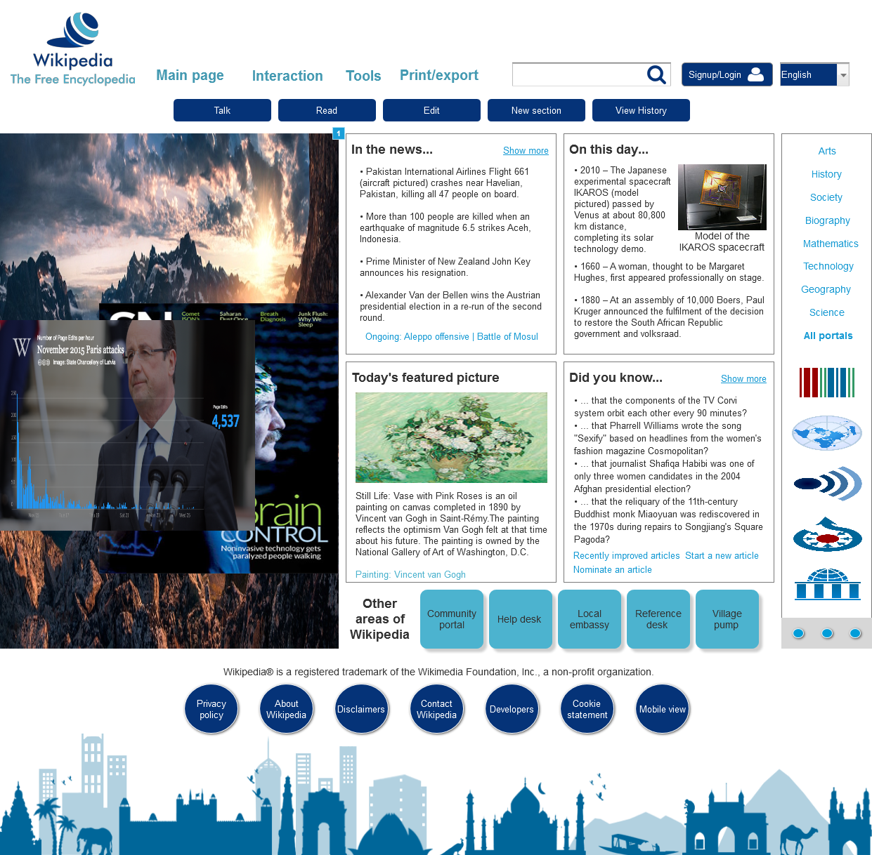

* + 1. Widget Table

|  |  |  |
| --- | --- | --- |
| Footnote | Name | Interactions |
| 1 | flipImg2 | OnLoad:  Case 1:  Set flipImg2 to Next flip down out 500ms flip up in 500ms wrap repeat every 5000 ms delay first change |
| 2 | flipImg1 | OnLoad:  Case 1:  Set flipImg1 to Next flip right out 500ms flip left in 500ms wrap repeat every 1000 ms delay first change |

* + 1. flipImg1
       1. State1
       2. User Interface



* + - 1. State2
      2. User Interface



* + - 1. State3
      2. User Interface

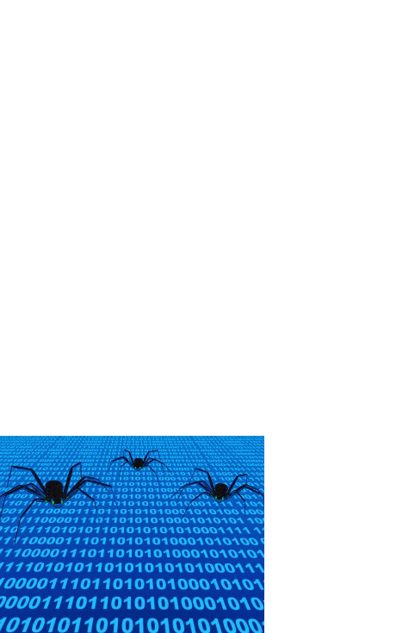

* + 1. Unnamed
       1. State1
    2. flipImg2
       1. State1
       2. User Interface

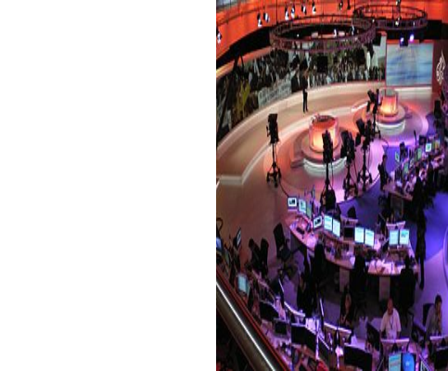

* + - 1. State2
      2. User Interface

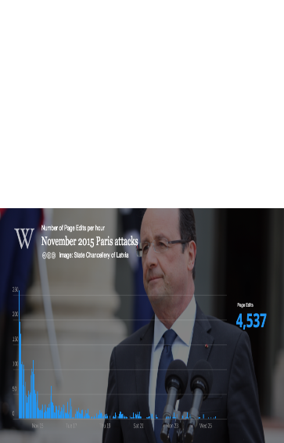

* + - 1. State3
      2. User Interface

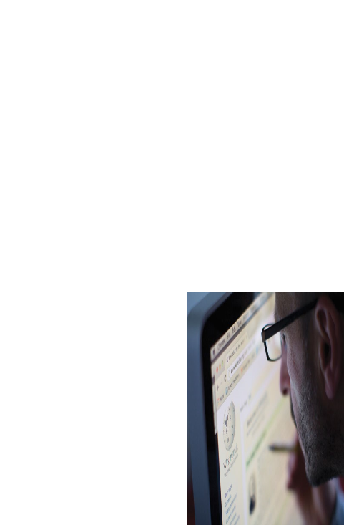

* 1. Akshay_ChangeDate
     1. User Interface

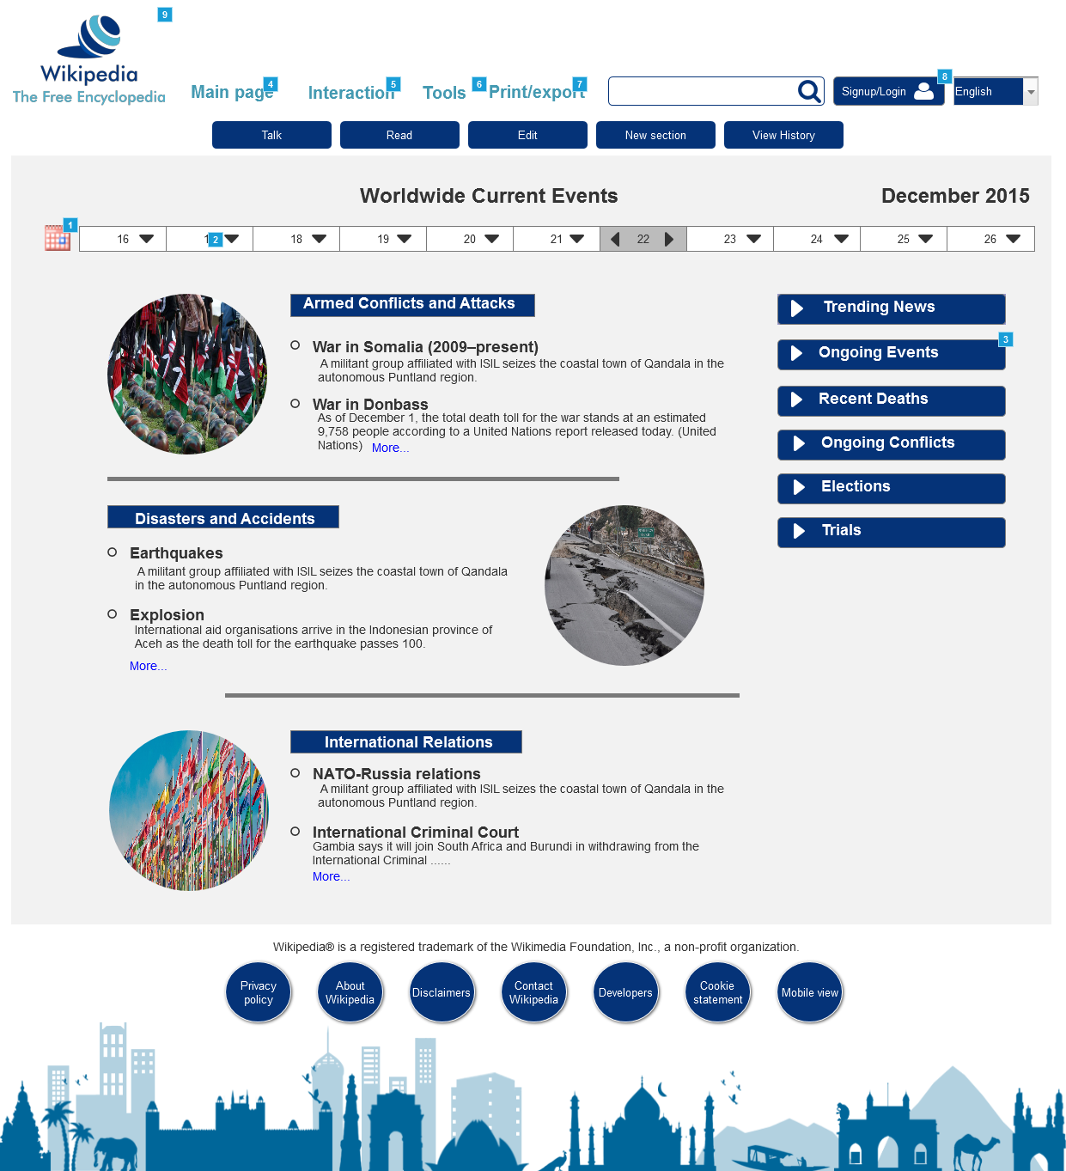

* + 1. Widget Table

|  |  |  |
| --- | --- | --- |
| Footnote | Name | Interactions |
| 1 | Calendar Icon Button | OnClick:  Case 1:  Toggle Date Calendar Show fade 50 ms Hide none 500 ms  Bring Date Calendar to Front |
| 2 | Date Calendar | OnShow:  Case 1:  Set text on Current Date1 equal to "[[MonthName]] [[Year]]" |
| 3 | ONGOING EVENTS | OnMove:  Case 1:  Move SECTION3 with this |
| 4 |  | OnClick:  Case 1:  Toggle MainPageDP bring to front  Hide Interaction_DP  Hide Tools_DP  Hide Print_DP |
| 5 |  | OnClick:  Case 1:  Toggle Interaction_DP bring to front  Hide MainPageDP  Hide Print_DP  Hide Tools_DP |
| 6 |  | OnClick:  Case 1:  Toggle Tools_DP  Hide Print_DP  Hide Interaction_DP  Hide MainPageDP |
| 7 |  | OnClick:  Case 1:  Toggle Print_DP  Hide Tools_DP  Hide Interaction_DP  Hide MainPageDP |
| 8 |  | OnClick:  Case 1:  Open Login Page_Garima Deshpande in Current Window |
| 9 |  | OnClick:  Case 1:  Open Home_Tejas in Current Window |

* + 1. ONGOING EVENTS
       1. State1
       2. User Interface



* + - 1. Widget Table

|  |  |  |
| --- | --- | --- |
| Footnote | Name | Interactions |
| 1 |  | OnClick:  Case 1:  Toggle CONTENT-SECTION2 |
| 2 | CONTENT-SECTION2 | OnShow:  Case 1:  Move SECTION3 by (0,154) OnHide:  Case 1:  Move SECTION3 by (0,-154) |

* + 1. CONTENT-SECTION2
       1. State1
       2. User Interface

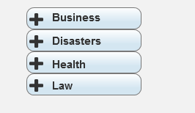

* + 1. TRENDING NEWS
       1. State1
       2. User Interface



* + - 1. Widget Table

|  |  |  |
| --- | --- | --- |
| Footnote | Name | Interactions |
| 1 |  | OnClick:  Case 1:  Toggle CONTENT-SECTION1 |
| 2 | CONTENT-SECTION1 | OnShow:  Case 1:  Move ONGOING EVENTS by (0,154) OnHide:  Case 1:  Move ONGOING EVENTS by (0,-154) |

* + 1. CONTENT-SECTION1
       1. State1
       2. User Interface

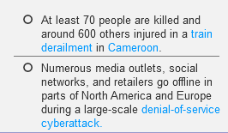

* + 1. MainPageDP
       1. State1
       2. User Interface

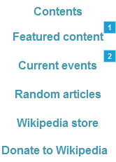

* + - 1. Widget Table

|  |  |
| --- | --- |
| Footnote | Interactions |
| 1 | OnClick:  Case 1:  Open Featured_Content_Tejas in Current Window |
| 2 | OnClick:  Case 1:  Open Akshay_CurrentEvents in Current Window |

* + 1. Interaction_DP
       1. State1
       2. User Interface

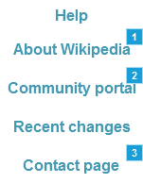

* + - 1. Widget Table

|  |  |
| --- | --- |
| Footnote | Interactions |
| 1 | OnClick:  Case 1:  Open About_Us_Tejas in Current Window |
| 2 | OnClick:  Case 1:  Open Akshay_CommunityPortal in Current Window |
| 3 | OnClick:  Case 1:  Open ContactUs_PriyankaPagare in Current Window |

* + 1. Tools_DP
       1. State1
       2. User Interface

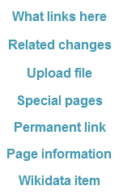

* + 1. Print_DP
       1. State1
       2. User Interface

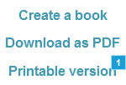

* + - 1. Widget Table

|  |  |
| --- | --- |
| Footnote | Interactions |
| 1 | OnClick:  Case 1:  Open Printable Version_Priyanka pagare in Current Window |

* + 1. SECTION3
       1. State1
       2. User Interface

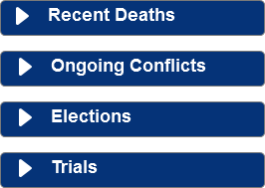

* + 1. Date Calendar
       1. Default
       2. User Interface

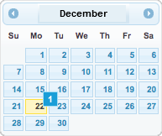

* + - 1. Widget Table

|  |  |  |
| --- | --- | --- |
| Footnote | Name | Interactions |
| 1 | Date Selection | OnClick:  Case 1:  Open Link in Current Window |

* 1. Akshay_CurrentEvents
     1. User Interface

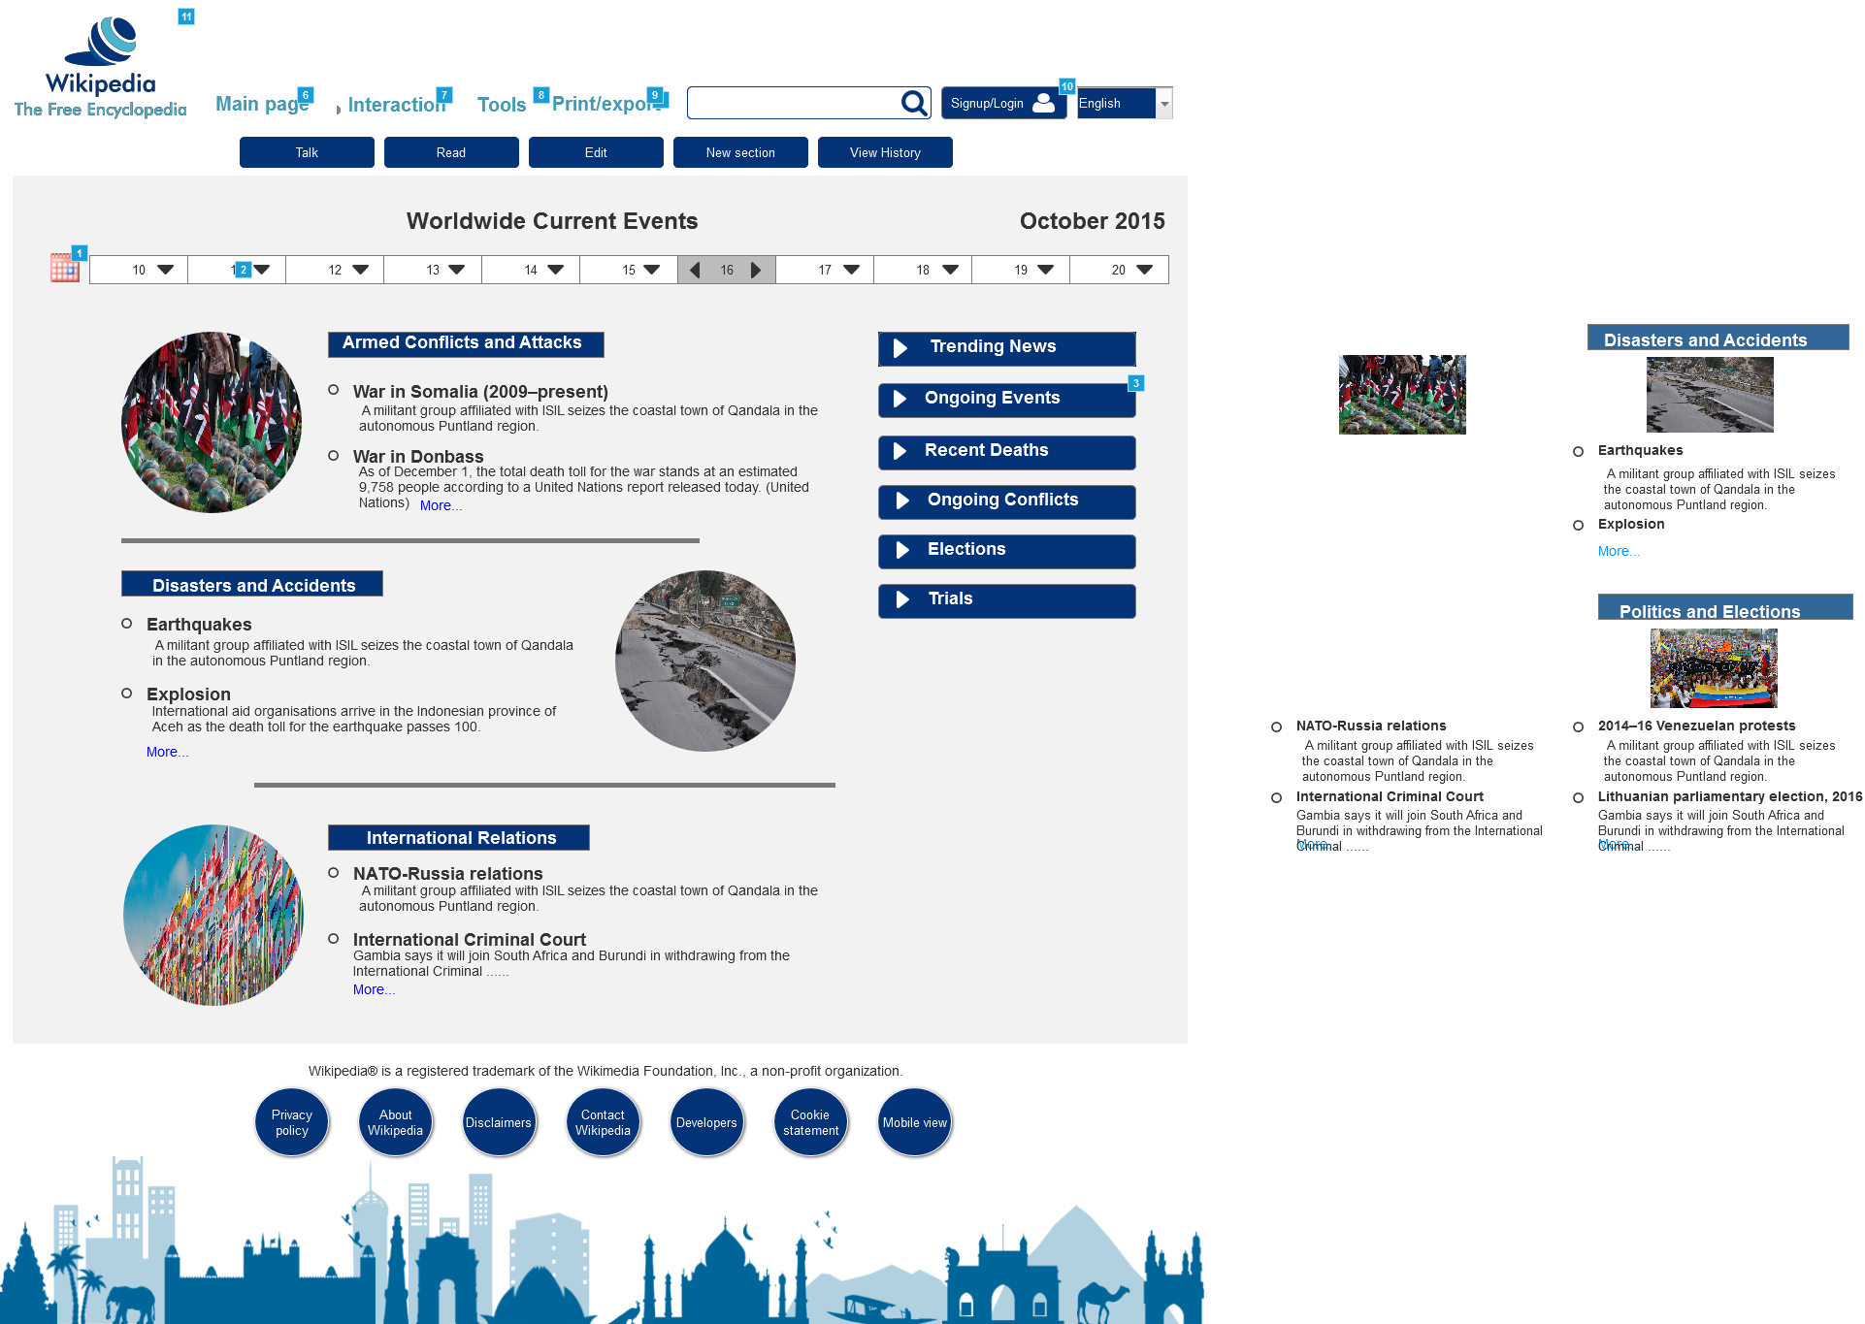

* + 1. Widget Table

|  |  |  |
| --- | --- | --- |
| Footnote | Name | Interactions |
| 1 | Calendar Icon Button | OnClick:  Case 1:  Toggle Date Calendar Show fade 50 ms Hide none 500 ms  Bring Date Calendar to Front |
| 2 | Date Calendar | OnShow:  Case 1:  Set text on Current Date1 equal to "[[MonthName]] [[Year]]" |
| 3 | ONGOING EVENTS | OnMove:  Case 1:  Move SECTION3 with this |
| 4 |  | OnClick:  Case 1:  Open Akshay_CurrentEvents in Current Window |
| 5 |  | OnClick:  Case 1:  Show This, Hide (Group), (Rectangle), (Rectangle), (Rectangle), (Rectangle), (Rectangle) |
| 6 |  | OnClick:  Case 1:  Toggle MainPageDP bring to front  Hide Interaction_DP  Hide Tools_DP  Hide Print_DP |
| 7 |  | OnClick:  Case 1:  Toggle Interaction_DP bring to front  Hide MainPageDP  Hide Print_DP  Hide Tools_DP |
| 8 |  | OnClick:  Case 1:  Toggle Tools_DP  Hide Print_DP  Hide Interaction_DP  Hide MainPageDP |
| 9 |  | OnClick:  Case 1:  Toggle Print_DP  Hide Tools_DP  Hide Interaction_DP  Hide MainPageDP |
| 10 |  | OnClick:  Case 1:  Open Login Page_Garima Deshpande in Current Window |
| 11 |  | OnClick:  Case 1:  Open Home_Tejas in Current Window |

* + 1. ONGOING EVENTS
       1. State1
       2. User Interface



* + - 1. Widget Table

|  |  |  |
| --- | --- | --- |
| Footnote | Name | Interactions |
| 1 |  | OnClick:  Case 1:  Toggle CONTENT-SECTION2 |
| 2 | CONTENT-SECTION2 | OnShow:  Case 1:  Move SECTION3 by (0,154) OnHide:  Case 1:  Move SECTION3 by (0,-154) |

* + 1. CONTENT-SECTION2
       1. State1
       2. User Interface



* + 1. TRENDING NEWS
       1. State1
       2. User Interface



* + - 1. Widget Table

|  |  |  |
| --- | --- | --- |
| Footnote | Name | Interactions |
| 1 |  | OnClick:  Case 1:  Toggle CONTENT-SECTION1 |
| 2 | CONTENT-SECTION1 | OnShow:  Case 1:  Move ONGOING EVENTS by (0,154) OnHide:  Case 1:  Move ONGOING EVENTS by (0,-154) |

* + 1. CONTENT-SECTION1
       1. State1
       2. User Interface

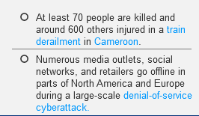

* + 1. SECTION3
       1. State1
       2. User Interface



* + 1. Date Calendar
       1. Default
       2. User Interface

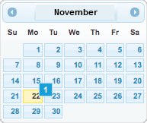

* + - 1. Widget Table

|  |  |  |
| --- | --- | --- |
| Footnote | Name | Interactions |
| 1 | Date Selection | OnClick:  Case 1:  Open Akshay_ChangeDate in Current Window |

* + 1. MainPageDP
       1. State1
       2. User Interface



* + - 1. Widget Table

|  |  |
| --- | --- |
| Footnote | Interactions |
| 1 | OnClick:  Case 1:  Open Featured_Content_Tejas in Current Window |
| 2 | OnClick:  Case 1:  Open Akshay_CurrentEvents in Current Window |

* + 1. Interaction_DP
       1. State1
       2. User Interface



* + - 1. Widget Table

|  |  |
| --- | --- |
| Footnote | Interactions |
| 1 | OnClick:  Case 1:  Open About_Us_Tejas in Current Window |
| 2 | OnClick:  Case 1:  Open Akshay_CommunityPortal in Current Window |
| 3 | OnClick:  Case 1:  Open ContactUs_PriyankaPagare in Current Window |

* + 1. Tools_DP
       1. State1
       2. User Interface



* + 1. Print_DP
       1. State1
       2. User Interface



* + - 1. Widget Table

|  |  |
| --- | --- |
| Footnote | Interactions |
| 1 | OnClick:  Case 1:  Open Printable Version_Priyanka pagare in Current Window |

* 1. Featured_Content_Tejas
     1. User Interface

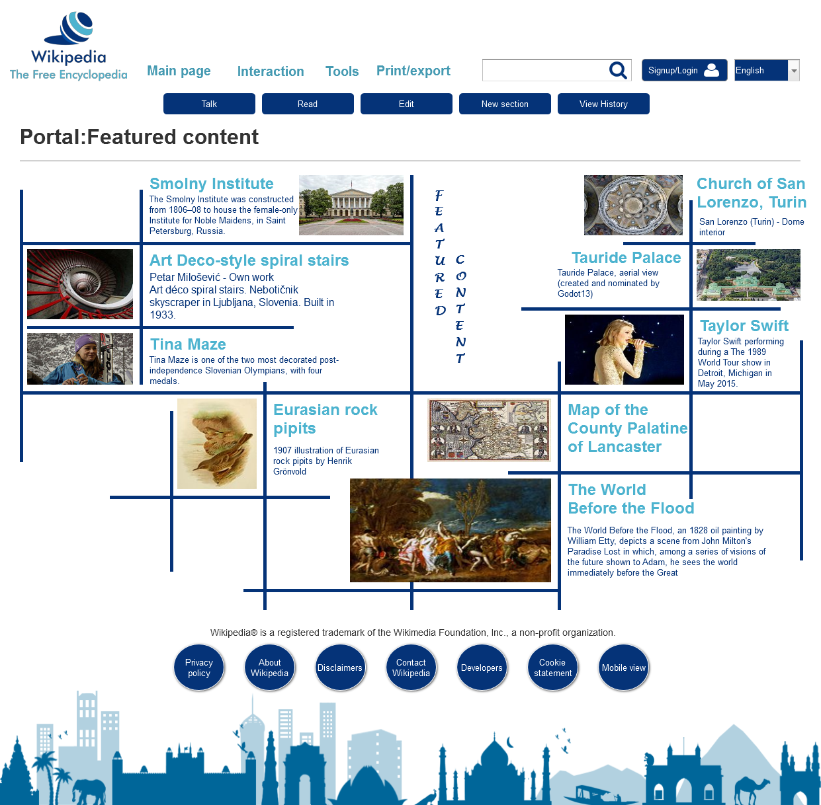

* 1. ContactUs_PriyankaPagare
     1. User Interface

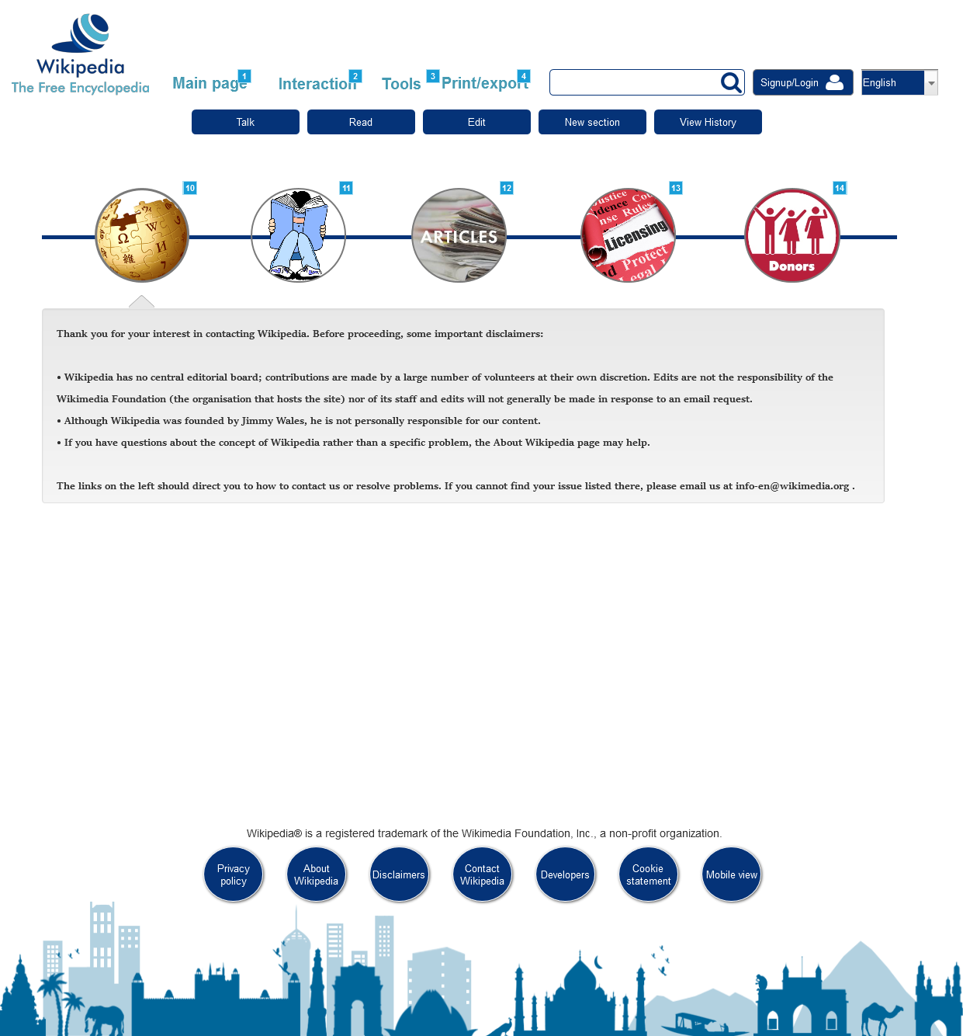

* + 1. Widget Table

|  |  |  |
| --- | --- | --- |
| Footnote | Name | Interactions |
| 1 |  | OnClick:  Case 1:  Toggle MainPageDP bring to front  Hide Interaction_DP  Hide Tools_DP  Show/Hide Widget |
| 2 |  | OnClick:  Case 1:  Toggle Interaction_DP bring to front  Hide MainPageDP  Show/Hide Widget  Hide Tools_DP |
| 3 |  | OnClick:  Case 1:  Toggle Tools_DP  Show/Hide Widget  Hide Interaction_DP  Hide MainPageDP |
| 4 |  | OnClick:  Case 1:  Show/Hide Widget  Hide Tools_DP  Hide Interaction_DP  Hide MainPageDP |
| 5 |  | OnClick:  Case 1:  Set (Dynamic Panel) to intro fade out 500ms fade in 500ms OnMouseHover:  Case 1:  Hide This flip right 500 ms  Show (Ellipse) fade 500 ms |
| 6 |  | OnClick:  Case 1:  Set (Dynamic Panel) to readers fade out 500ms fade in 500ms OnMouseHover:  Case 1:  Hide This flip right 500 ms  Show (Ellipse) fade 500 ms |
| 7 |  | OnClick:  Case 1:  Set (Dynamic Panel) to article fade out 500ms fade in 500ms OnMouseHover:  Case 1:  Hide This flip right 500 ms  Show (Ellipse) fade 500 ms |
| 8 |  | OnClick:  Case 1:  Set (Dynamic Panel) to license fade out 500ms fade in 500ms OnMouseHover:  Case 1:  Hide This flip right 500 ms  Show (Ellipse) fade 500 ms |
| 9 |  | OnClick:  Case 1:  Set (Dynamic Panel) to donor fade out 500ms fade in 500ms OnMouseHover:  Case 1:  Hide This flip right 500 ms  Show (Ellipse) fade 500 ms |
| 10 |  | OnMouseOut:  Case 1:  Hide (Ellipse) fade 500 ms  Show (Image) flip left 500 ms |
| 11 |  | OnMouseOut:  Case 1:  Hide (Ellipse) fade 500 ms  Show (Image) flip left 500 ms |
| 12 |  | OnMouseOut:  Case 1:  Hide (Ellipse) fade 500 ms  Show (Image) flip left 500 ms |
| 13 |  | OnMouseOut:  Case 1:  Hide This fade 500 ms  Show (Image) flip left 500 ms |
| 14 |  | OnMouseOut:  Case 1:  Hide This fade 500 ms  Show (Image) flip left 500 ms |

* + 1. Unnamed
       1. intro
       2. User Interface

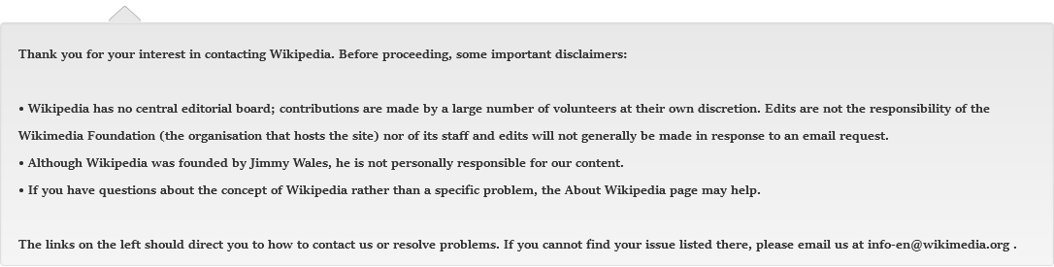

* + - 1. readers
      2. User Interface

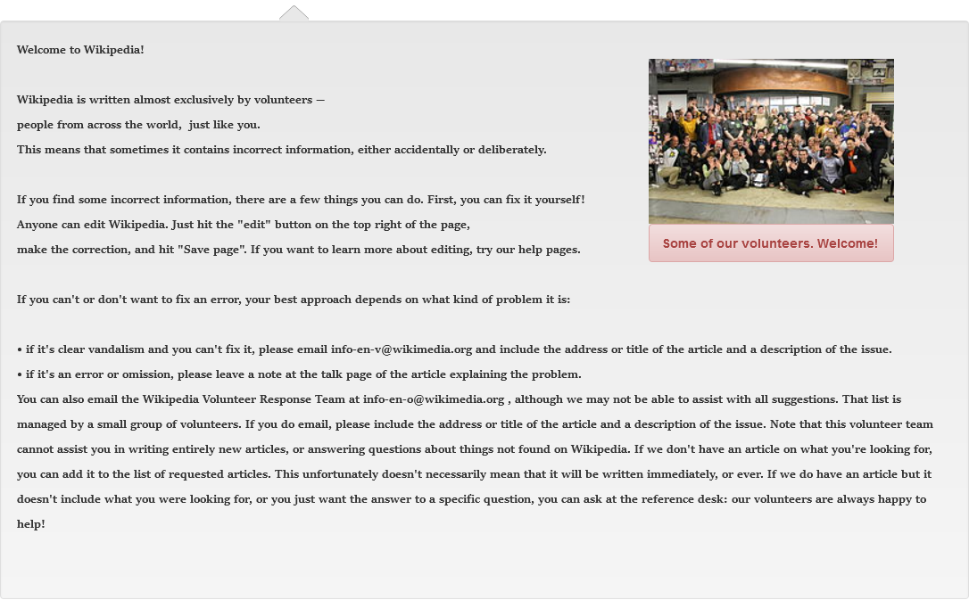

* + - 1. article
      2. User Interface

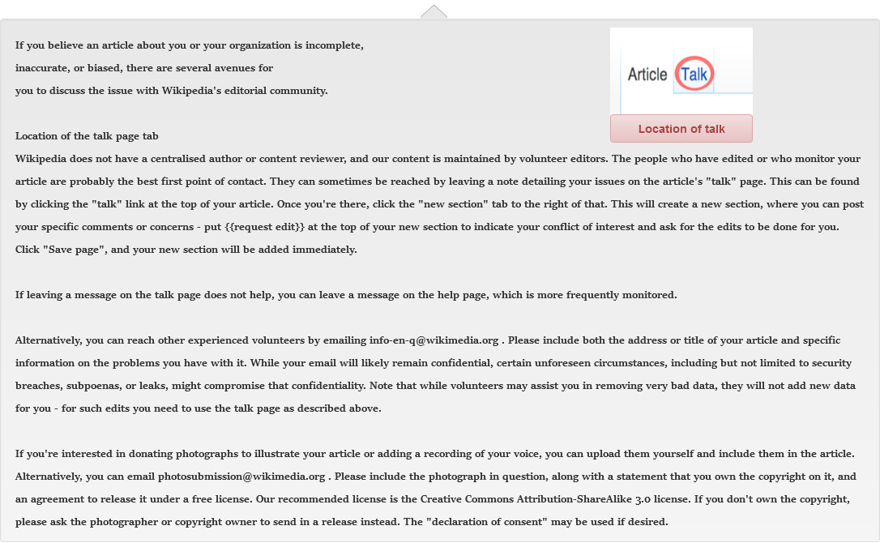

* + - 1. license
      2. User Interface

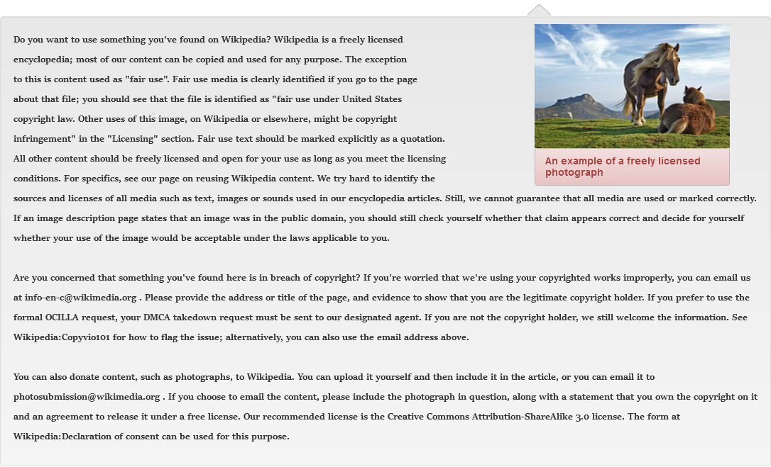

* + - 1. donor
      2. User Interface

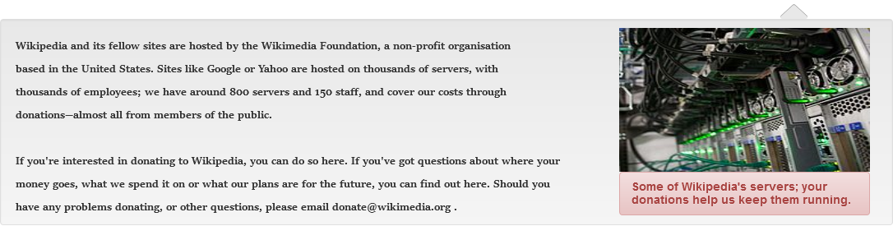

* + 1. Tools_DP
       1. State1
       2. User Interface



* + 1. Interaction_DP
       1. State1
       2. User Interface

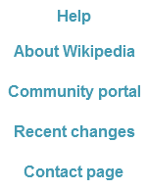

* + 1. MainPageDP
       1. State1
       2. User Interface

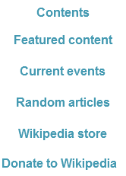

* 1. Akshay_CommunityPortal
     1. User Interface

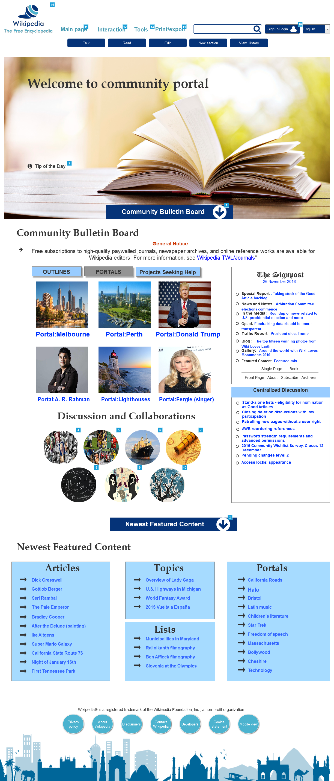

* + 1. Widget Table

|  |  |  |
| --- | --- | --- |
| Footnote | Name | Interactions |
| 1 |  | OnClick:  Case 1:  Scroll to Scroll1 (y only) swing 500ms |
| 2 |  | OnClick:  Case 1:  Show Modal Tip bring to front treat as lightbox  Bring Modal Tip to Front |
| 3 |  | OnClick:  Case 1:  Scroll to Scroll2 (y only) |
| 4 |  | OnMouseEnter:  Case 1:  Show Shadow1 bring to front OnMouseOut:  Case 1:  Hide Shadow1 |
| 5 |  | OnMouseEnter:  Case 1:  Show Shadow2 bring to front OnMouseOut:  Case 1:  Hide Shadow2 |
| 6 |  | OnMouseEnter:  Case 1:  Show Shadow3 bring to front OnMouseOut:  Case 1:  Hide Shadow3 |
| 7 |  | OnMouseEnter:  Case 1:  Show Shadow4 bring to front OnMouseOut:  Case 1:  Hide Shadow4 |
| 8 |  | OnMouseEnter:  Case 1:  Show Shadow5 bring to front OnMouseOut:  Case 1:  Hide Shadow5 |
| 9 |  | OnMouseEnter:  Case 1:  Show Shadow6 bring to front OnMouseOut:  Case 1:  Hide Shadow6 |
| 10 |  | OnMouseEnter:  Case 1:  Show Shadow7 bring to front OnMouseOut:  Case 1:  Hide Shadow7 |
| 11 |  | OnClick:  Case 1:  Toggle MainPageDP bring to front  Hide Interaction_DP  Hide Tools_DP  Hide Print_DP |
| 12 |  | OnClick:  Case 1:  Toggle Interaction_DP bring to front  Hide MainPageDP  Hide Print_DP  Hide Tools_DP |
| 13 |  | OnClick:  Case 1:  Toggle Tools_DP  Hide Print_DP  Hide Interaction_DP  Hide MainPageDP |
| 14 |  | OnClick:  Case 1:  Toggle Print_DP  Hide Tools_DP  Hide Interaction_DP  Hide MainPageDP |
| 15 |  | OnClick:  Case 1:  Open Login Page_Garima Deshpande in Current Window |
| 16 |  | OnClick:  Case 1:  Open Home_Tejas in Current Window |

* + 1. Modal Tip
       1. State1
       2. User Interface

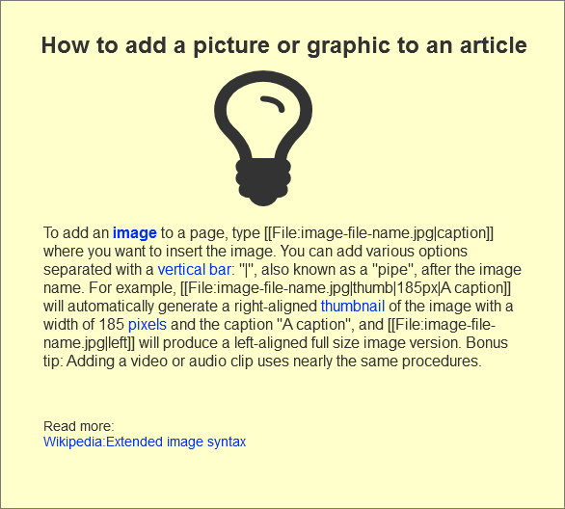

* + 1. Community contents
       1. State2
       2. User Interface

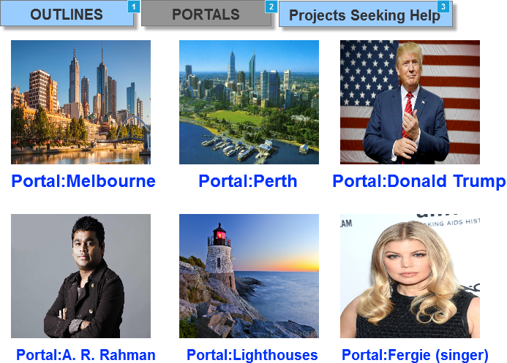

* + - 1. Widget Table

|  |  |
| --- | --- |
| Footnote | Interactions |
| 1 | OnClick:  Case 1:  Set Community contents to State1 |
| 2 | OnClick:  Case 1:  Set Community contents to State2 |
| 3 | OnClick:  Case 1:  Set Community contents to State3 |

* + - 1. State1
      2. User Interface

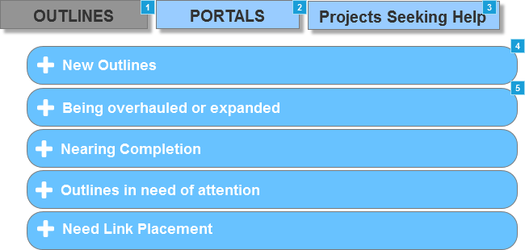

* + - 1. Widget Table

|  |  |  |
| --- | --- | --- |
| Footnote | Name | Interactions |
| 1 |  | OnClick:  Case 1:  Set Community contents to State1 |
| 2 |  | OnClick:  Case 1:  Set Community contents to State2 |
| 3 |  | OnClick:  Case 1:  Set Community contents to State3 |
| 4 | New Outlines | OnClick:  Case 1:  Toggle Contents-New Outlines |
| 5 | Section2 | OnMove:  Case 1:  Move Section3 with this |

* + - 1. State3
      2. User Interface

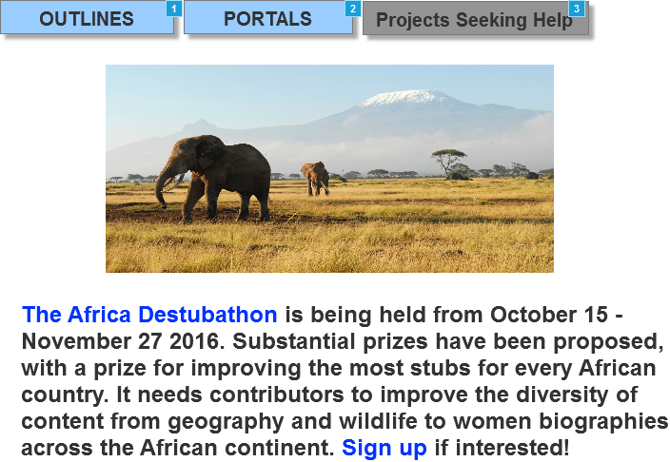

* + - 1. Widget Table

|  |  |
| --- | --- |
| Footnote | Interactions |
| 1 | OnClick:  Case 1:  Set Community contents to State1 |
| 2 | OnClick:  Case 1:  Set Community contents to State2 |
| 3 | OnClick:  Case 1:  Set Community contents to State3 |

* + 1. New Outlines
       1. State1
       2. User Interface



* + - 1. Widget Table

|  |  |  |
| --- | --- | --- |
| Footnote | Name | Interactions |
| 1 | Contents-New Outlines | OnShow:  Case 1:  Move Section2 by (0,153) OnHide:  Case 1:  Move Section2 by (0,-153) |

* + 1. Contents-New Outlines
       1. State1
       2. User Interface

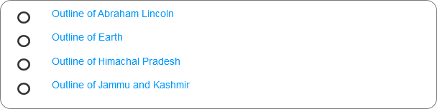

* + 1. Section2
       1. State1
       2. User Interface



* + 1. Section3
       1. State1
       2. User Interface

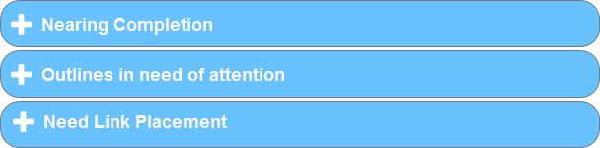

* + 1. Shadow1
       1. State1
       2. User Interface



* + 1. Shadow2
       1. State1
       2. User Interface



* + 1. Shadow3
       1. State1
       2. User Interface



* + 1. Shadow4
       1. State1
       2. User Interface



* + 1. Shadow5
       1. State1
       2. User Interface



* + 1. Shadow6
       1. State1
       2. User Interface



* + 1. Shadow7
       1. State1
       2. User Interface



* + 1. MainPageDP
       1. State1
       2. User Interface



* + - 1. Widget Table

|  |  |
| --- | --- |
| Footnote | Interactions |
| 1 | OnClick:  Case 1:  Open Featured_Content_Tejas in Current Window |
| 2 | OnClick:  Case 1:  Open Akshay_CurrentEvents in Current Window |

* + 1. Interaction_DP
       1. State1
       2. User Interface



* + - 1. Widget Table

|  |  |
| --- | --- |
| Footnote | Interactions |
| 1 | OnClick:  Case 1:  Open About_Us_Tejas in Current Window |
| 2 | OnClick:  Case 1:  Open Akshay_CommunityPortal in Current Window |
| 3 | OnClick:  Case 1:  Open ContactUs_PriyankaPagare in Current Window |

* + 1. Tools_DP
       1. State1
       2. User Interface



* + 1. Print_DP
       1. State1
       2. User Interface



* + - 1. Widget Table

|  |  |
| --- | --- |
| Footnote | Interactions |
| 1 | OnClick:  Case 1:  Open Printable Version_Priyanka pagare in Current Window |

* 1. About_Us_Tejas
     1. User Interface

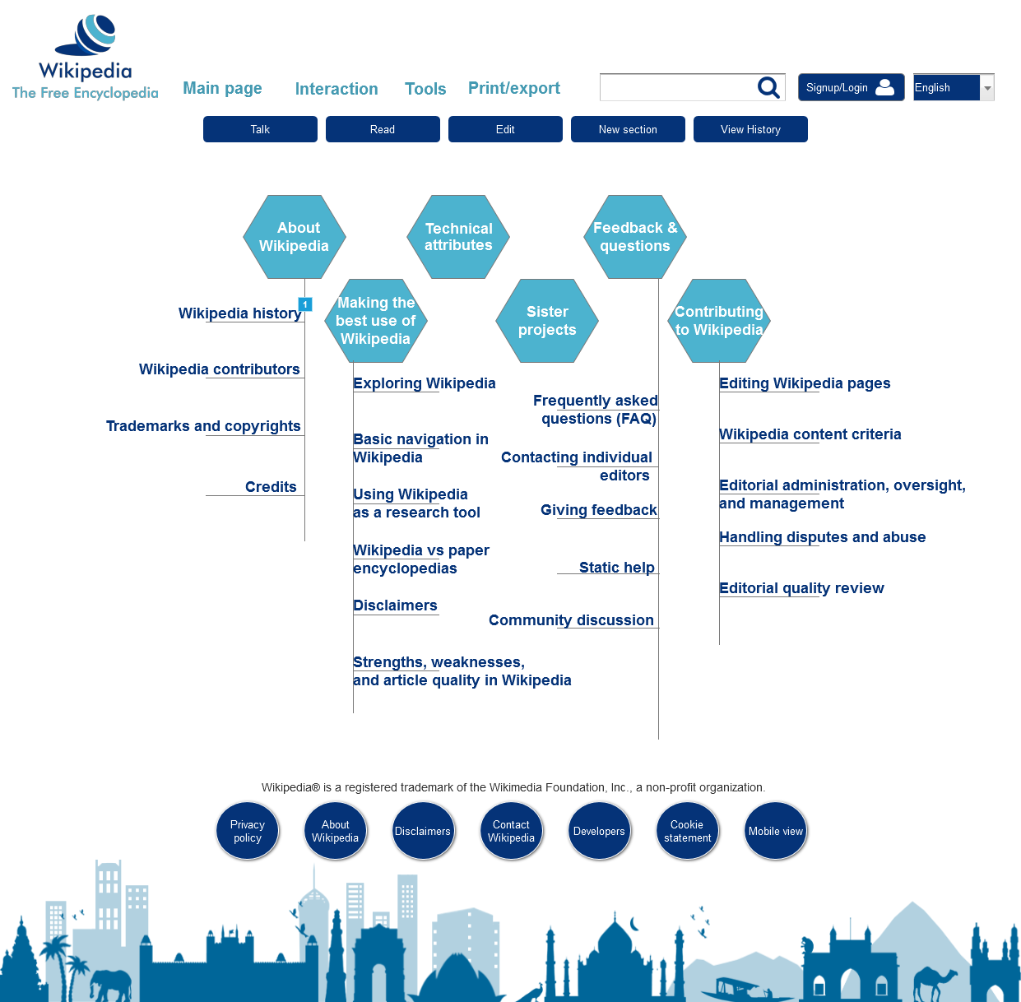

* + 1. Widget Table

|  |  |  |
| --- | --- | --- |
| Footnote | Name | Interactions |
| 1 |  | OnClick:  Case 1:  Toggle AboutUs bring to front |

* + 1. AboutUs
       1. State1
       2. User Interface

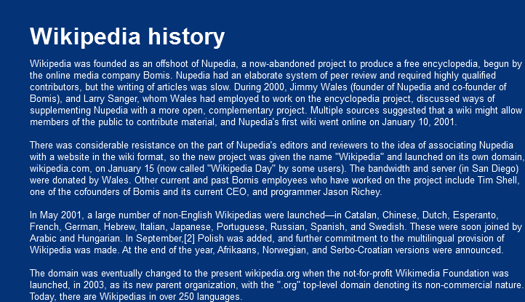

* 1. Printable Version_Priyanka pagare
     1. User Interface

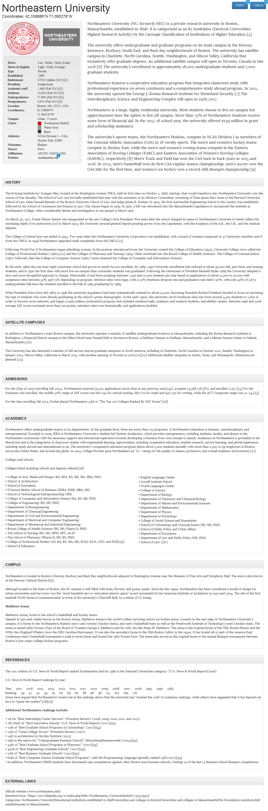

* + 1. Widget Table

|  |  |
| --- | --- |
| Footnote | Interactions |
| 1 | OnClick:  Case 1: |
| 2 | OnClick:  Case 1:  Wait 1 ms  Open Link in Current Window |
| 3 | OnClick:  Case 1:  Wait 1 ms  Open Link in Current Window |

* 1. Home_Tejas_AfterLogin
     1. User Interface

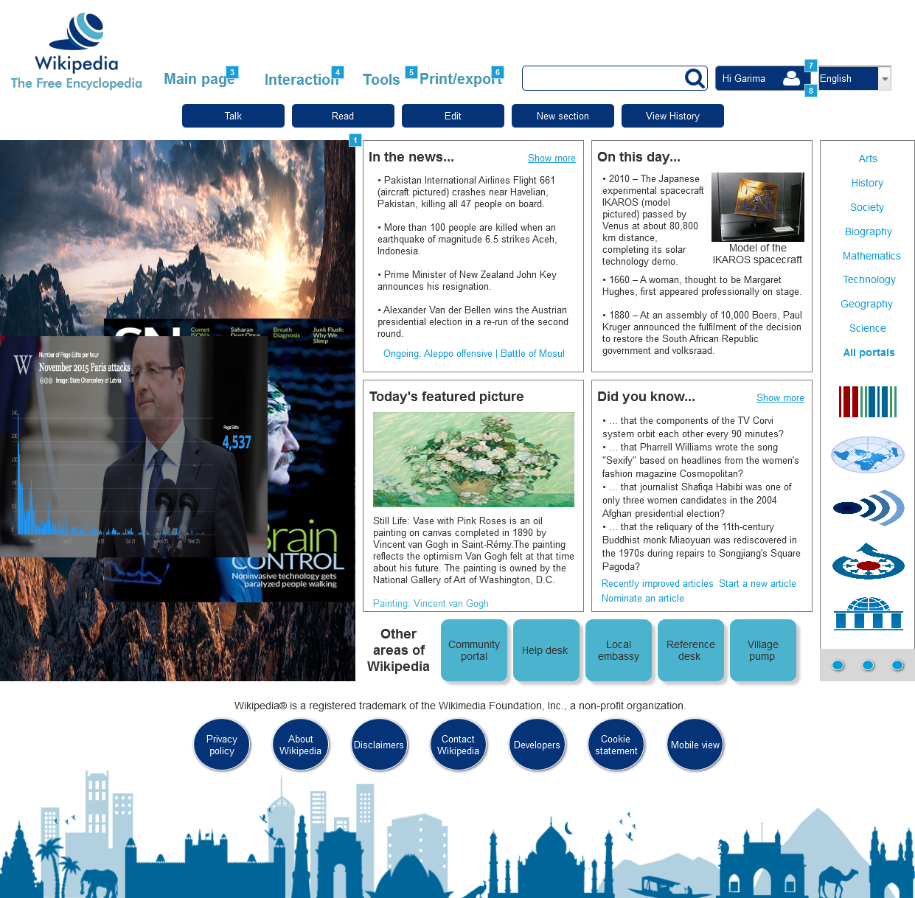

* + 1. Widget Table

|  |  |  |
| --- | --- | --- |
| Footnote | Name | Interactions |
| 1 | flipImg2 | OnLoad:  Case 1:  Set flipImg2 to Next flip down out 500ms flip up in 500ms wrap repeat every 5000 ms delay first change |
| 2 | flipImg1 | OnLoad:  Case 1:  Set flipImg1 to Next flip right out 500ms flip left in 500ms wrap repeat every 1000 ms delay first change |
| 3 |  | OnClick:  Case 1:  Toggle MainPageDP bring to front  Hide Interaction_DP  Hide Tools_DP  Hide Print_DP |
| 4 |  | OnClick:  Case 1:  Toggle Interaction_DP bring to front  Hide MainPageDP  Hide Print_DP  Hide Tools_DP |
| 5 |  | OnClick:  Case 1:  Toggle Tools_DP  Hide Print_DP  Hide Interaction_DP  Hide MainPageDP |
| 6 |  | OnClick:  Case 1:  Toggle Print_DP  Hide Tools_DP  Hide Interaction_DP  Hide MainPageDP |
| 7 |  | OnMouseOut:  Case 1:  Hide logout panel OnMouseHover:  Case 1:  Show logout panel treat as flyout |
| 8 | logout panel | OnClick:  Onclick:  Open Home_Tejas in Current Window OnFocus:  Case 1:  Show logout panel |

* + 1. flipImg1
       1. State1
       2. User Interface



* + - 1. State2
      2. User Interface



* + - 1. State3
      2. User Interface



* + 1. Unnamed
       1. State1
    2. flipImg2
       1. State1
       2. User Interface



* + - 1. State2
      2. User Interface



* + - 1. State3
      2. User Interface



* + 1. MainPageDP
       1. State1
       2. User Interface



* + 1. Interaction_DP
       1. State1
       2. User Interface



* + 1. Tools_DP
       1. State1
       2. User Interface



* + 1. Print_DP
       1. State1
       2. User Interface

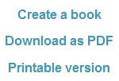

* + 1. logout panel
       1. State1
       2. User Interface



* 1. Login Page_Garima Deshpande
     1. User Interface

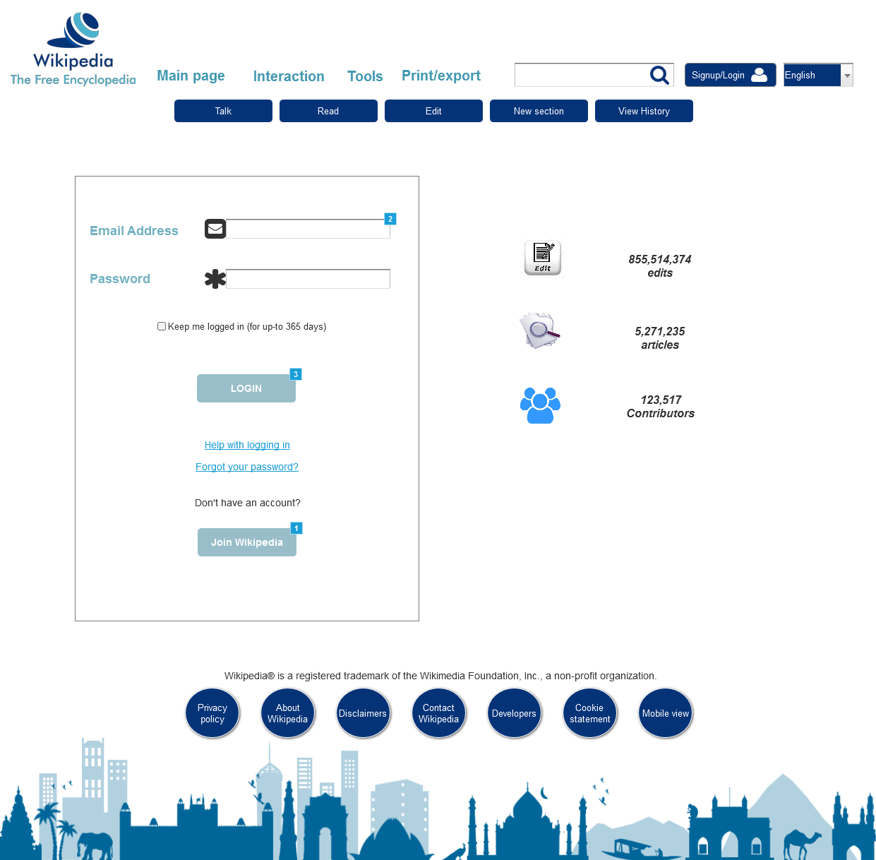

* + 1. Widget Table

|  |  |  |
| --- | --- | --- |
| Footnote | Name | Interactions |
| 1 |  | OnClick:  Case 1:  Open Signup Page_Garima Deshpande in Current Window |
| 2 | emailaddress | OnTextChange:  Case 1  (If text on This equals "garima@gmail.com"):  Hide emailid not exist  Case 1  (Else If text on This does not equal "garima@gmail.com"):  Show emailid not exist |
| 3 |  | OnClick:  Case 1  (If text on emailaddress equals "" or text on password equals ""):  Set Error message panel to State1 fade out 500ms fade in 500ms show if hidden  Case 1  (Else If text on emailaddress does not equal "garima@gmail.com" or text on password does not equal "Abc123def"):  Set Error message panel to State2 fade out 500ms fade in 500ms show if hidden  Case 1  (Else If text on emailaddress equals "garima@gmail.com" and text on password equals "Abc123def"):  Open Home_Tejas_AfterLogin in Current Window |

* + 1. emailid not exist
       1. State1
       2. User Interface



* + 1. Error message panel
       1. State1
       2. User Interface

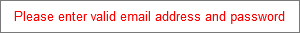

* + - 1. State2
      2. User Interface



* 1. Signup Page_Garima Deshpande
     1. User Interface

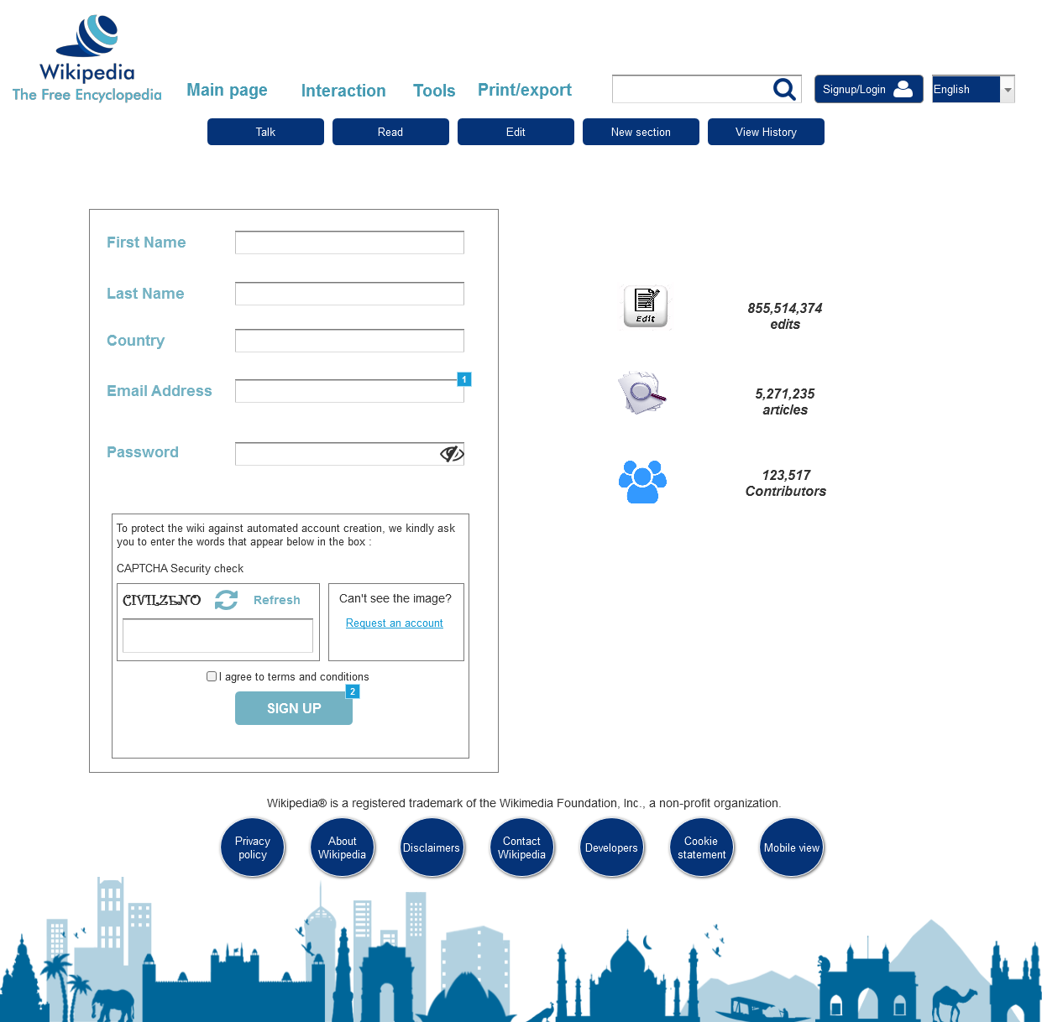

* + 1. Widget Table

|  |  |  |
| --- | --- | --- |
| Footnote | Name | Interactions |
| 1 | emailaddress textfield | OnTextChange:  Case 1  (If text on This equals "garima@gmail.com"):  Hide EmailId exists panel  Case 1  (Else If text on This does not equal "garima@gmail.com"):  Show EmailId exists panel |
| 2 |  | OnClick:  Case 1  (If text on firstname textfield equals "" or text on lastname textfield equals "" or text on country textfield equals "" or text on emailaddress textfield equals "" or text on password textfield equals "" or text on captcha textfield equals "" or is selected of Checkbox equals false):  Show emptyvalue panel treat as flyout  Case 1  (Else If True):  Open Home_Tejas_AfterLogin in Current Window |

* + 1. EmailId exists panel
       1. State1
       2. User Interface



* + 1. emptyvalue panel
       1. State1
       2. User Interface



* + 1. Unnamed
       1. State1
       2. User Interface



* + - 1. Widget Table

|  |  |  |
| --- | --- | --- |
| Footnote | Name | Interactions |
| 1 | password textfield | OnTextChange:  Case 1  (If text on This equals "Abc123def"):  Hide Password guide panel  Case 1  (Else If text on This does not equal "Abc123def"):  Show Password guide panel |
| 2 |  | OnClick:  Case 1:  Set (Dynamic Panel) to State2  Set text on password textfield equal to text on password textfield |

* + - 1. State2
      2. User Interface



* + - 1. Widget Table

|  |  |  |
| --- | --- | --- |
| Footnote | Name | Interactions |
| 1 | password textfield | OnTextChange:  Case 1  (If text on This equals "Abc123def"):  Hide Password guide panel  Case 1  (Else If text on This does not equal "Abc123def"):  Show Password guide panel |
| 2 |  | OnClick:  Case 1:  Set (Dynamic Panel) to State1  Set text on password textfield equal to text on password textfield |

* + 1. Password guide panel
       1. State1
       2. User Interface

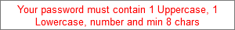

* 1. Search_Page_PriyankaPagare
     1. User Interface

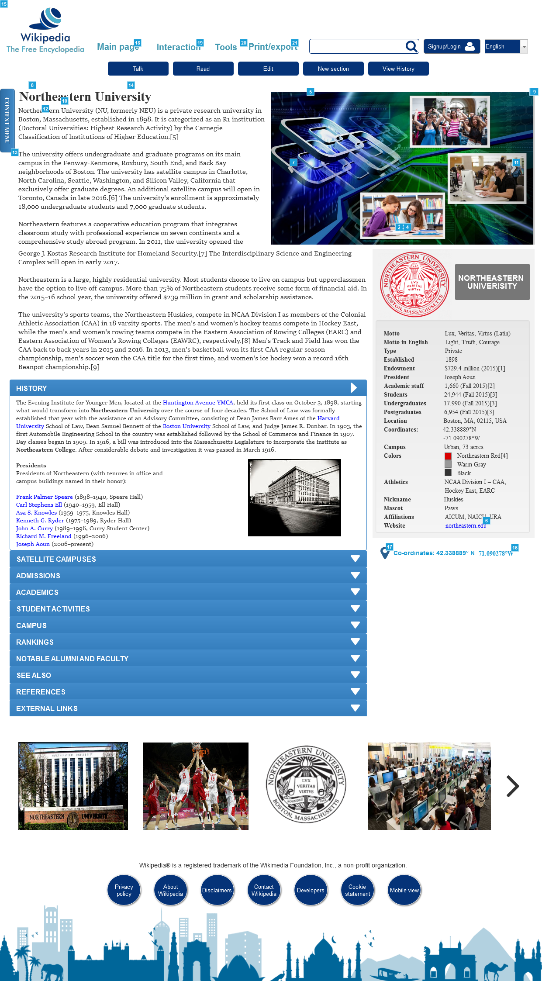

* + 1. Widget Table

|  |  |  |
| --- | --- | --- |
| Footnote | Name | Interactions |
| 1 | Carousel DP | OnPanelStateChange:  Case 1  (If state of Carousel DP equals First slide):  Set is selected of Slider Button 1 equal to "true", and  is selected of Slider Button 3 equal to "false", and  is selected of Slider Button 2 equal to "false"  Set This to Second slide slide left out 5000ms slide left in 5000ms show if hidden  Case 2  (Else If state of Carousel DP equals Second slide):  Set is selected of Slider Button 1 equal to "false", and  is selected of Slider Button 2 equal to "true", and  is selected of Slider Button 3 equal to "false"  Set This to Third slide slide left out 5000ms slide left in 5000ms show if hidden  Case 3  (Else If state of Carousel DP equals Third slide):  Set is selected of Slider Button 1 equal to "false", and  is selected of Slider Button 2 equal to "false", and  is selected of Slider Button 3 equal to "true"  Set This to First slide slide left out 5000ms slide left in 5000ms show if hidden OnLoad:  Case 1  (If state of Carousel DP equals First slide):  Set This to Second slide slide left out 5000ms slide left in 5000ms show if hidden  Case 1  (Else If state of Carousel DP equals Second slide):  Set This to Third slide slide left out 5000ms slide left in 5000ms show if hidden  Case 1  (Else If state of Carousel DP equals Third slide):  Set This to First slide slide left out 5000ms slide left in 5000ms show if hidden |
| 2 | Slider Button 1 | OnClick:  Case 1:  Set is selected of Slider Button 1 equal to "true", and  is selected of Slider Button 2 equal to "false", and  is selected of Slider Button 3 equal to "false"  Set Carousel DP to First slide slide right out 600ms slide right in 600ms |
| 3 | Slider Button 2 | OnClick:  Case 1  (If state of Carousel DP equals First slide):  Set is selected of Slider Button 1 equal to "false", and  is selected of Slider Button 2 equal to "true", and  is selected of Slider Button 3 equal to "false"  Set Carousel DP to Second slide slide left out 600ms slide left in 600ms  Case 2  (Else If True):  Set Carousel DP to Second slide slide right out 600ms slide right in 600ms  Set is selected of Slider Button 1 equal to "false", and  is selected of Slider Button 2 equal to "true", and  is selected of Slider Button 3 equal to "false" |
| 4 | Slider Button 3 | OnClick:  Case 1:  Set is selected of Slider Button 1 equal to "false", and  is selected of Slider Button 2 equal to "false", and  is selected of Slider Button 3 equal to "true"  Set Carousel DP to Third slide slide left out 600ms slide left in 600ms |
| 5 | Carousel Panel Left | OnClick:  Case 1:  Show/Hide Widget  Set Carousel DP to Previous slide right out 600ms slide right in 600ms wrap  Wait 601 ms OnMouseEnter:  Case 1:  Set is selected of Chevron Left equal to "true"  Set is selected of Carousel Panel Left equal to "true" OnMouseOut:  Case 1:  Set is selected of Chevron Left equal to "false"  Set is selected of Carousel Panel Left equal to "false" |
| 6 |  | OnClick:  Case 1:  Open http://northeastern.edu in Current Window |
| 7 | Chevron Left | OnClick:  Case 1:  Show/Hide Widget  Set Carousel DP to Previous slide right out 600ms slide right in 600ms wrap  Wait 601 ms  Show/Hide Widget OnMouseEnter:  Case 1:  Set is selected of Chevron Left equal to "true"  Set is selected of Carousel Panel Left equal to "true" OnMouseOut:  Case 1:  Set is selected of Chevron Left equal to "false"  Set is selected of Carousel Panel Left equal to "false" |
| 8 |  | OnClick:  Case 1:  Set (Dynamic Panel) to History  Scroll to (Dynamic Panel) (y only) linear 500ms  Show (Rectangle) slide right 500 ms, Hide (Rectangle) slide left 500 ms, (Rectangle) slide left 500 ms |
| 9 | Carousel Panel Right | OnClick:  Case 1:  Show/Hide Widget  Set Carousel DP to Next slide left out 600ms slide left in 600ms wrap  Wait 601 ms  Show/Hide Widget OnMouseEnter:  Case 1:  Set is selected of Chevron Right equal to "true"  Set is selected of Carousel Panel Right equal to "true" OnMouseOut:  Case 1:  Set is selected of Chevron Right equal to "false"  Set is selected of Carousel Panel Right equal to "false" |
| 10 |  | OnClick:  Case 1:  Set (Dynamic Panel) to Salelitte Campuses  Scroll to (Dynamic Panel) (y only) linear 500ms  Show (Rectangle) slide right 500 ms, Hide (Rectangle) slide left 500 ms, (Rectangle) slide left 500 ms |
| 11 | Chevron Right | OnClick:  Case 1:  Show/Hide Widget  Set Carousel DP to Next slide left out 600ms slide left in 600ms wrap  Wait 601 ms OnMouseEnter:  Case 1:  Set is selected of Chevron Right equal to "true"  Set is selected of Carousel Panel Right equal to "true" OnMouseOut:  Case 1:  Set is selected of Chevron Right equal to "false"  Set is selected of Carousel Panel Right equal to "false" |
| 12 |  | OnClick:  Case 1:  Set (Dynamic Panel) to Admissions  Scroll to (Dynamic Panel) (y only) linear 500ms  Show (Rectangle) slide right 500 ms, Hide (Rectangle) slide left 500 ms, (Rectangle) slide left 500 ms |
| 13 |  | OnClick:  Case 1:  Wait 1 ms  Show (Rectangle) slide right 500 ms, (Rectangle) slide right 500 ms  Hide This fade 500 ms |
| 14 |  | OnClick:  Case 1:  Wait 1 ms  Hide This slide left 500 ms, (Rectangle) slide left 500 ms  Show (Rectangle) slide right 500 ms |
| 15 |  | OnClick:  Case 1:  Show (Rectangle) slide left 500 ms, (Rectangle) slide left 500 ms  Hide This fade 500 ms |
| 16 |  | OnClick:  Case 1  (If visibility of (Group) equals true):  Hide (Group) slide up 500 ms  Case 1  (Else If visibility of (Group) equals false):  Show (Group) slide down 500 ms |
| 17 |  | OnClick:  Case 1  (If visibility of (Group) equals true):  Hide (Group) slide up 500 ms  Case 1  (Else If visibility of (Group) equals false):  Show (Group) slide down 500 ms |
| 18 |  | OnClick:  Case 1:  Toggle MainPageDP bring to front  Hide Interaction_DP  Hide Tools_DP  Hide Print_DP |
| 19 |  | OnClick:  Case 1:  Toggle Interaction_DP bring to front  Hide MainPageDP  Hide Print_DP  Hide Tools_DP |
| 20 |  | OnClick:  Case 1:  Toggle Tools_DP  Hide Print_DP  Hide Interaction_DP  Hide MainPageDP |
| 21 |  | OnClick:  Case 1:  Toggle Print_DP  Hide Tools_DP  Hide Interaction_DP  Hide MainPageDP |

* + 1. Carousel DP
       1. First slide
       2. User Interface



* + - 1. Second slide
      2. User Interface

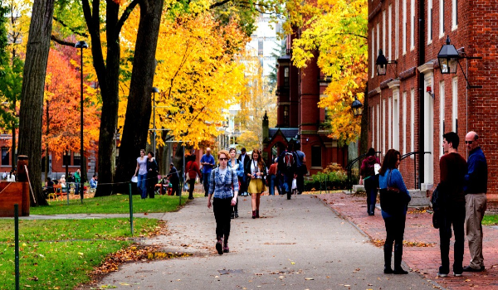

* + - 1. Third slide
      2. User Interface

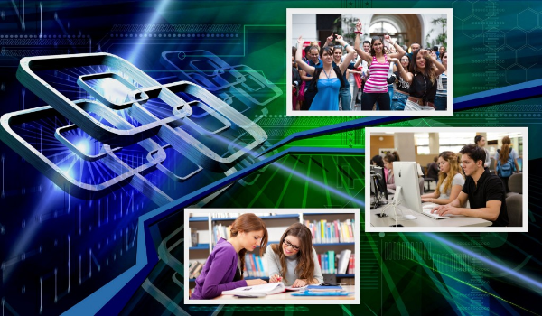

* + 1. Unnamed
       1. History
       2. User Interface

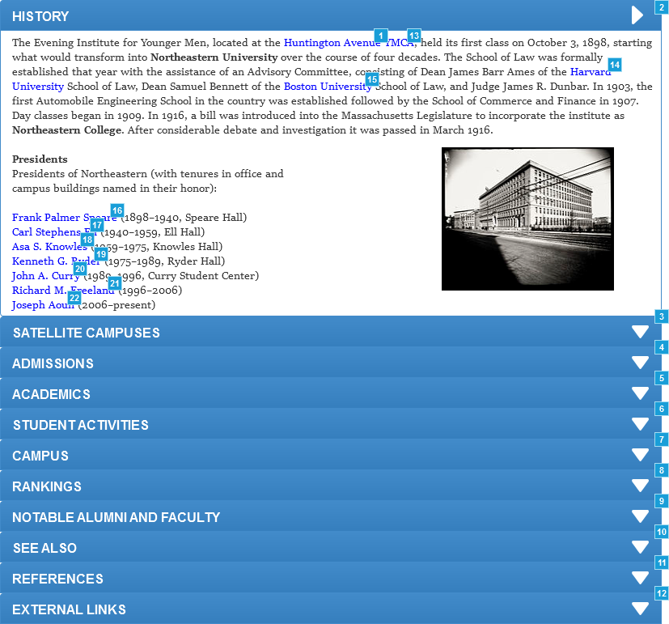

* + - 1. Widget Table

|  |  |
| --- | --- |
| Footnote | Interactions |
| 1 | OnClick:  Case 1:  Open https://en.wikipedia.org/wiki/Huntington_Avenue in Current Window |
| 2 | OnClick:  Case 1:  Set (Dynamic Panel) to All closed slide up out 500ms slide down in 500ms |
| 3 | OnClick:  Case 1:  Set (Dynamic Panel) to Salelitte Campuses slide up out 500ms slide down in 500ms |
| 4 | OnClick:  Case 1:  Set (Dynamic Panel) to Admissions slide up out 500ms slide down in 500ms |
| 5 | OnClick:  Case 1:  Set (Dynamic Panel) to State |
| 6 | OnClick:  Case 1:  Set (Dynamic Panel) to State |
| 7 | OnClick:  Case 1:  Set (Dynamic Panel) to State |
| 8 | OnClick:  Case 1:  Set (Dynamic Panel) to State |
| 9 | OnClick:  Case 1:  Set (Dynamic Panel) to State |
| 10 | OnClick:  Case 1:  Set (Dynamic Panel) to State |
| 11 | OnClick:  Case 1:  Set (Dynamic Panel) to State |
| 12 | OnClick:  Case 1:  Set (Dynamic Panel) to State |
| 13 | OnClick:  Case 1:  Open https://en.wikipedia.org/wiki/YMCA in Current Window |
| 14 | OnClick:  Case 1:  Open https://en.wikipedia.org/wiki/Harvard_University in Current Window |
| 15 | OnClick:  Case 1:  Open https://en.wikipedia.org/wiki/Boston_University in Current Window |
| 16 | OnClick:  Case 1:  Open https://en.wikipedia.org/wiki/Frank_Palmer_Speare in Current Window |
| 17 | OnClick:  Case 1:  Open https://en.wikipedia.org/wiki/Carl_Stephens_Ell in Current Window |
| 18 | OnClick:  Case 1:  Open https://en.wikipedia.org/wiki/Asa_S._Knowles in Current Window |
| 19 | OnClick:  Case 1:  Open https://en.wikipedia.org/wiki/Kenneth_G._Ryder in Current Window |
| 20 | OnClick:  Case 1:  Open https://en.wikipedia.org/wiki/John_A._Curry in Current Window |
| 21 | OnClick:  Case 1:  Open https://en.wikipedia.org/wiki/Richard_M._Freeland in Current Window |
| 22 | OnClick:  Case 1:  Open https://en.wikipedia.org/wiki/Joseph_Aoun in Current Window |

* + - 1. Salelitte Campuses
      2. User Interface

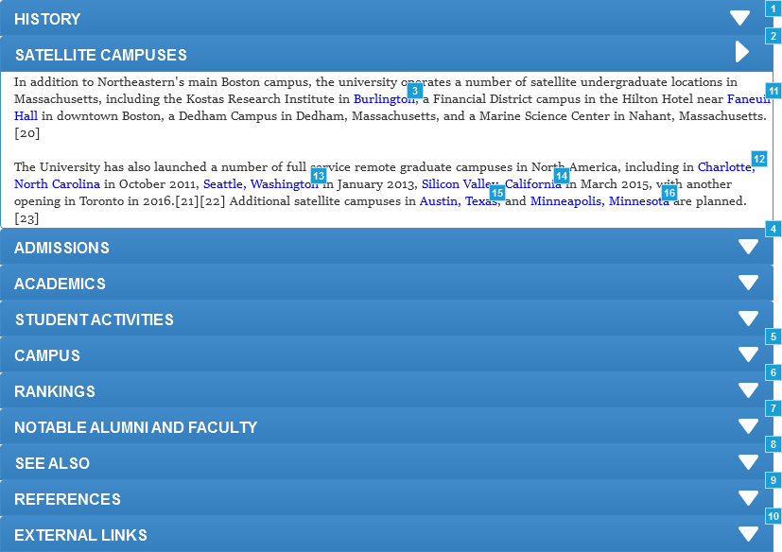

* + - 1. Widget Table

|  |  |
| --- | --- |
| Footnote | Interactions |
| 1 | OnClick:  Case 1:  Set (Dynamic Panel) to History slide up out 500ms slide down in 500ms |
| 2 | OnClick:  Case 1:  Set (Dynamic Panel) to All closed slide up out 500ms slide down in 500ms |
| 3 | OnClick:  Case 1:  Open https://en.wikipedia.org/wiki/Burlington,_Massachusetts in Current Window |
| 4 | OnClick:  Case 1:  Set (Dynamic Panel) to Admissions slide up out 500ms slide down in 500ms |
| 5 | OnClick:  Case 1: |
| 6 | OnClick:  Case 1: |
| 7 | OnClick:  Case 1: |
| 8 | OnClick:  Case 1: |
| 9 | OnClick:  Case 1: |
| 10 | OnClick:  Case 1: |
| 11 | OnClick:  Case 1:  Open https://en.wikipedia.org/wiki/Faneuil_Hall in Current Window |
| 12 | OnClick:  Case 1:  Open https://en.wikipedia.org/wiki/Charlotte,_North_Carolina in Current Window |
| 13 | OnClick:  Case 1:  Open https://en.wikipedia.org/wiki/Seattle,_Washington in Current Window |
| 14 | OnClick:  Case 1:  Open https://en.wikipedia.org/wiki/Silicon_Valley,_California in Current Window |
| 15 | OnClick:  Case 1:  Open https://en.wikipedia.org/wiki/Austin,_Texas in Current Window |
| 16 | OnClick:  Case 1:  Open https://en.wikipedia.org/wiki/Minneapolis,_Minnesota in Current Window |

* + - 1. Admissions
      2. User Interface

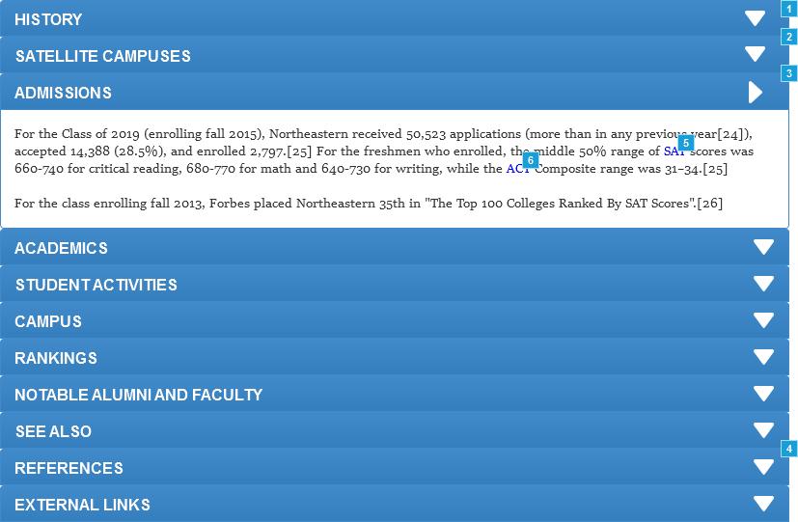

* + - 1. Widget Table

|  |  |
| --- | --- |
| Footnote | Interactions |
| 1 | OnClick:  Case 1:  Set (Dynamic Panel) to History slide up out 500ms slide down in 500ms |
| 2 | OnClick:  Case 1:  Set (Dynamic Panel) to Salelitte Campuses slide up out 500ms slide down in 500ms |
| 3 | OnClick:  Case 1:  Set (Dynamic Panel) to All closed slide up out 500ms slide down in 500ms |
| 4 | OnClick:  Case 1: |
| 5 | OnClick:  Case 1:  Open https://en.wikipedia.org/wiki/SAT in Current Window |
| 6 | OnClick:  Case 1:  Open https://en.wikipedia.org/wiki/ACT_(examination) in Current Window |

* + - 1. All closed
      2. User Interface

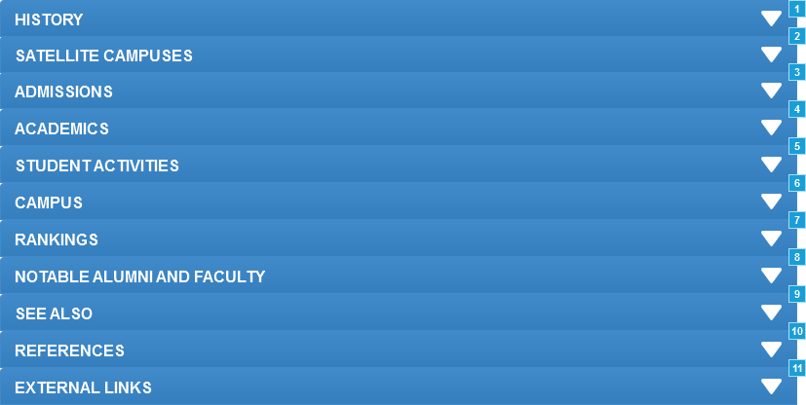

* + - 1. Widget Table

|  |  |
| --- | --- |
| Footnote | Interactions |
| 1 | OnClick:  Case 1:  Set (Dynamic Panel) to History slide up out 500ms slide down in 500ms |
| 2 | OnClick:  Case 1:  Set (Dynamic Panel) to Salelitte Campuses slide up out 500ms slide down in 500ms |
| 3 | OnClick:  Case 1:  Set (Dynamic Panel) to Admissions slide up out 500ms slide down in 500ms |
| 4 | OnClick:  Case 1:  Set (Dynamic Panel) to State |
| 5 | OnClick:  Case 1:  Set (Dynamic Panel) to State |
| 6 | OnClick:  Case 1:  Set (Dynamic Panel) to State |
| 7 | OnClick:  Case 1:  Set (Dynamic Panel) to State |
| 8 | OnClick:  Case 1:  Set (Dynamic Panel) to State |
| 9 | OnClick:  Case 1:  Set (Dynamic Panel) to State |
| 10 | OnClick:  Case 1:  Set (Dynamic Panel) to State |
| 11 | OnClick:  Case 1:  Set (Dynamic Panel) to State |

* + 1. Unnamed
       1. Images1
       2. User Interface

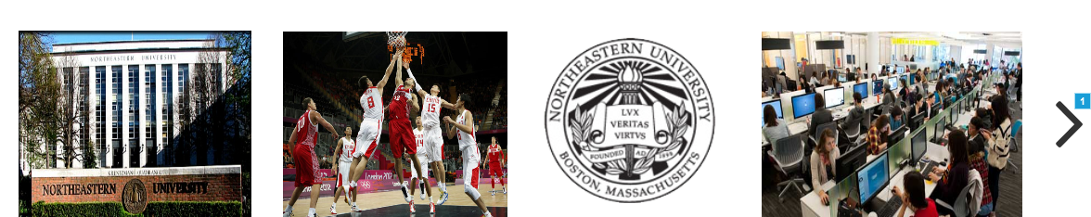

* + - 1. Widget Table

|  |  |
| --- | --- |
| Footnote | Interactions |
| 1 | OnClick:  Case 1:  Set (Dynamic Panel) to Images2 slide left out 1000ms slide left in 1000ms |

* + - 1. Images2
      2. User Interface

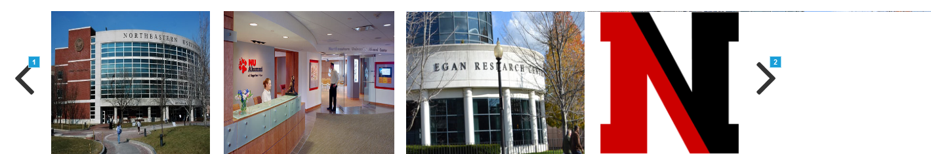

* + - 1. Widget Table

|  |  |
| --- | --- |
| Footnote | Interactions |
| 1 | OnClick:  Case 1:  Set (Dynamic Panel) to Images1 slide right out 1000ms slide right in 1000ms |
| 2 | OnClick:  Case 1:  Set (Dynamic Panel) to Images3 slide left out 1000ms slide left in 1000ms |

* + - 1. Images3
      2. User Interface

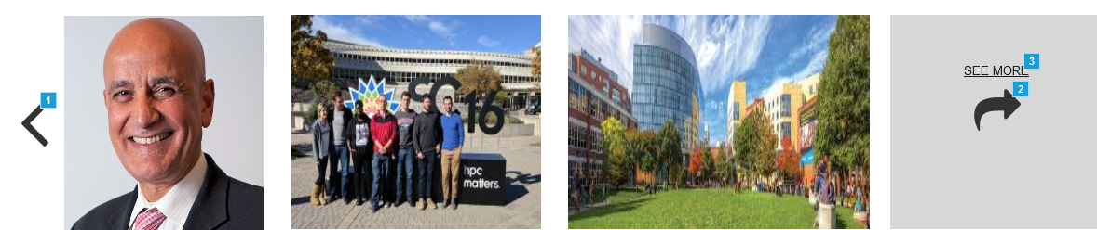

* + - 1. Widget Table

|  |  |
| --- | --- |
| Footnote | Interactions |
| 1 | OnClick:  Case 1:  Set (Dynamic Panel) to Images2 slide right out 1000ms slide right in 1000ms |
| 2 | OnClick:  Case 1:  Open https://www.google.com/search?q=northeastern+university&source=lnms&tbm=isch&sa=X&ved=0ahUKEwiu1YvqlebQAhUH-GMKHe9mC3IQ_AUICigD&biw=1366&bih=638 in New Window/Tab |
| 3 | OnClick:  Case 1:  Open https://www.google.com/search?q=northeastern+university&source=lnms&tbm=isch&sa=X&ved=0ahUKEwiu1YvqlebQAhUH-GMKHe9mC3IQ_AUICigD&biw=1366&bih=638 in New Window/Tab |

* + 1. Map Area
       1. Default
       2. User Interface

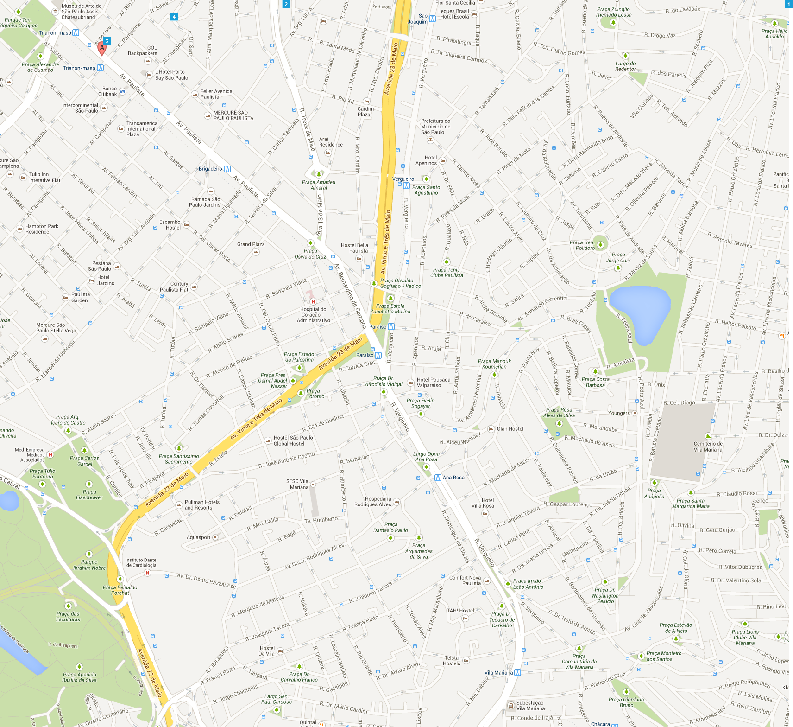

* + - 1. Widget Table

|  |  |  |
| --- | --- | --- |
| Footnote | Name | Interactions |
| 1 | Map | OnMove:  Case 1:  Move Pin: A with this OnDrag:  Case 1:  Move Map with drag |
| 2 | Details Block | OnShow:  Case 1:  Move Map by (-100,0) elastic 400ms OnHide:  Case 1:  Move Map by (100,0) swing 200ms |
| 3 | Pin: A | OnMove:  Case 1:  Move Info: A with this OnDragStart:  Case 1:  Hide Info: A fade 100 ms OnDrag:  Case 1:  Move Pin: A with drag |
| 4 | Info: A | OnLoad:  Case 1:  Hide This |

* + 1. Loading
       1. Default
       2. User Interface



* + 1. Map
       1. Default Image
       2. User Interface

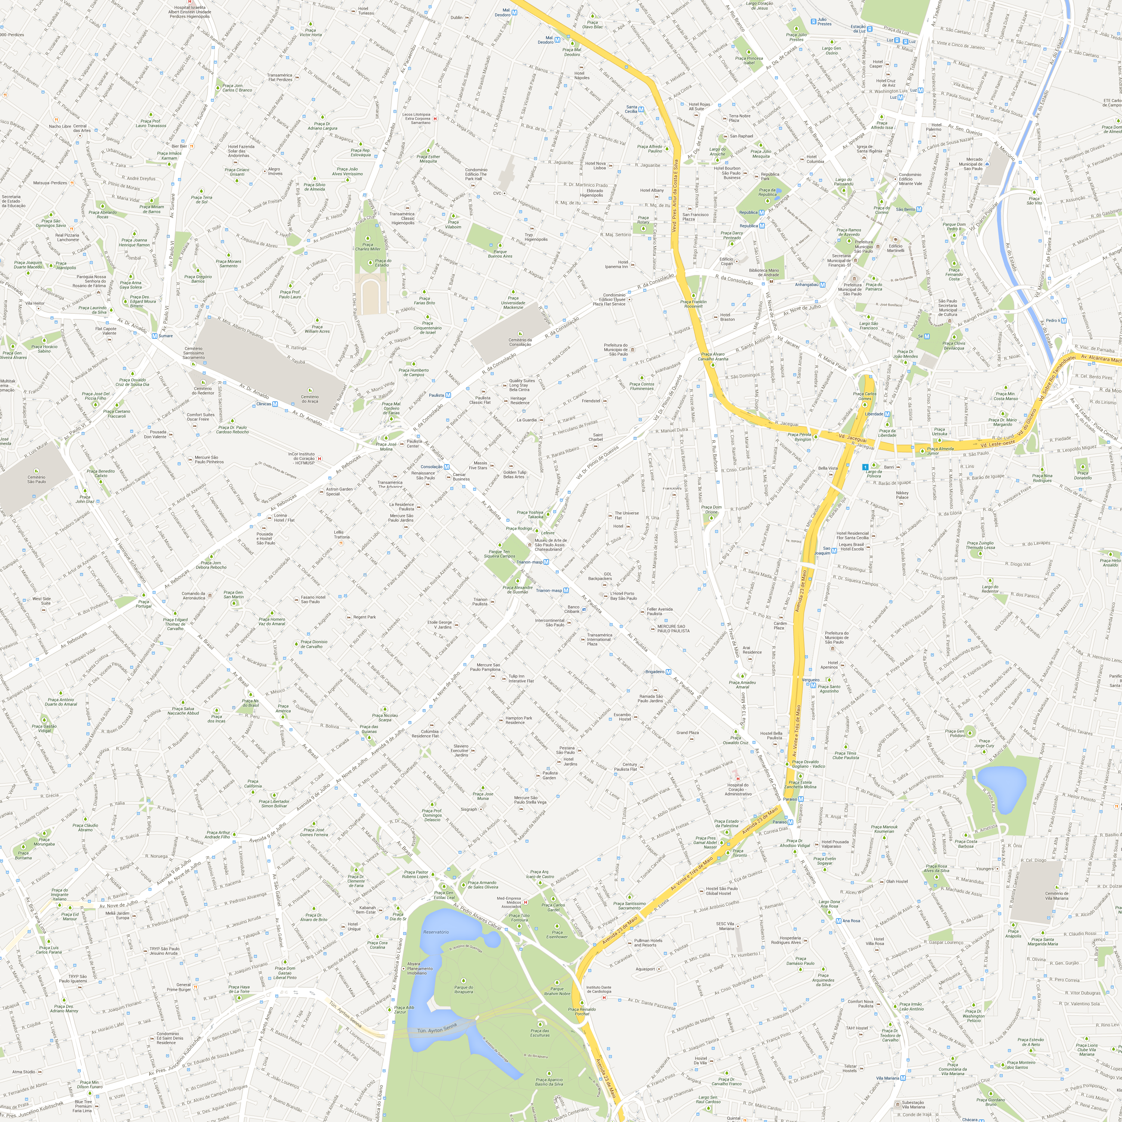

* + - 1. Widget Table

|  |  |  |
| --- | --- | --- |
| Footnote | Name | Interactions |
| 1 | Warning regions | OnLoad:  Case 1:  Hide This |

* + 1. Warning regions
       1. Red
       2. User Interface



* + 1. Pin: A
       1. Default
       2. User Interface



* + - 1. Widget Table

|  |  |
| --- | --- |
| Footnote | Interactions |
| 1 | OnClick:  Case 1:  Toggle Info: A Show fade 200 ms Hide fade 200 ms |

* + 1. Info: A
       1. Default
       2. User Interface

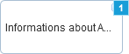

* + - 1. Widget Table

|  |  |
| --- | --- |
| Footnote | Interactions |
| 1 | OnClick:  Case 1:  Hide Info: A |

* + 1. Details Block
       1. Map Deails
       2. User Interface

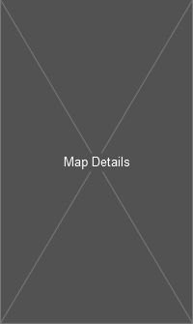

* + 1. Print_DP
       1. State1
       2. User Interface



* + 1. Tools_DP
       1. State1
       2. User Interface



* + 1. Interaction_DP
       1. State1
       2. User Interface



* + 1. MainPageDP
       1. State1
       2. User Interface



1. Masters
   1. Master List

Master

* 1. Master
     1. User Interface



* + 1. Widget Table

|  |  |  |
| --- | --- | --- |
| Footnote | Name | Interactions |
| 1 |  | OnClick:  Case 1:  Toggle MainPageDP bring to front  Hide Interaction_DP  Hide Tools_DP  Hide Print_DP |
| 2 |  | OnClick:  Case 1:  Toggle Interaction_DP bring to front  Hide MainPageDP  Hide Print_DP  Hide Tools_DP |
| 3 |  | OnClick:  Case 1:  Toggle Tools_DP  Hide Print_DP  Hide Interaction_DP  Hide MainPageDP |
| 4 |  | OnClick:  Case 1:  Toggle Print_DP  Hide Tools_DP  Hide Interaction_DP  Hide MainPageDP |
| 5 |  | OnClick:  Case 1:  Open Login Page_Garima Deshpande in Current Window |
| 6 |  | OnClick:  Case 1:  Open Home_Tejas in Current Window |
| 7 |  | OnClick:  Case 1  (If text on Search equals "Northeastern" or text on Search contains "Northeastern" or text on Search equals "northeastern" or text on Search contains "northeastern"):  Open Search_Page_PriyankaPagare in Current Window |

* + 1. MainPageDP
       1. State1
       2. User Interface



* + - 1. Widget Table

|  |  |
| --- | --- |
| Footnote | Interactions |
| 1 | OnClick:  Case 1:  Open Featured_Content_Tejas in Current Window |
| 2 | OnClick:  Case 1:  Open Akshay_CurrentEvents in Current Window |

* + 1. Interaction_DP
       1. State1
       2. User Interface



* + - 1. Widget Table

|  |  |
| --- | --- |
| Footnote | Interactions |
| 1 | OnClick:  Case 1:  Open About_Us_Tejas in Current Window |
| 2 | OnClick:  Case 1:  Open Akshay_CommunityPortal in Current Window |
| 3 | OnClick:  Case 1:  Open ContactUs_PriyankaPagare in Current Window |

* + 1. Tools_DP
       1. State1
       2. User Interface



* + 1. Print_DP
       1. State1
       2. User Interface



* + - 1. Widget Table

|  |  |
| --- | --- |
| Footnote | Interactions |
| 1 | OnClick:  Case 1:  Open Printable Version_Priyanka pagare in Current Window |